Lab 1: Uploading a Web page to a server

***In this class, all labs and projects will be uploaded to the University’s web server, and you will turn in the url of the uploaded lab via canvas. To be clear, the url that you will submit via canvas should start with http://... (If the url you turn in starts with File:///, it is the incorrect url and the TA will not be able to see your lab.)***

**Lab Overview:**

1. ***Have or install a text editor (Step 1, below)***
2. ***Install software for establishing a VPN (Step 2, below)***
3. ***Install software for uploading files to the University’s server (Step 3, below)***
4. ***Edit an html file as described in the lab, below***
5. ***Upload lab1 folder to the university’s web server***
6. ***Have or install Google Chrome and Firefox on your laptop***
7. ***Test the files you uploaded on both Google Chrome and Firefox***
8. ***Turn in the url (web address) of the lab1 you uploaded to canvas***

***A large part of this lab is installing software that you will be using for both this lab and future labs. Please make sure you’ve installed the appropriate software.***

For this lab you will be uploading a web page to a University server. The web page you will be uploading is one created by me and consists of the web page itself (basic1.html), its associated css styles (basic.css), and two image files: url.jpg and binnumtunnel.jpg. All of these files can be found on my web site under Labs/Lab1. You will edit basic1.html using a text editor (following instructions at <https://www.eecis.udel.edu/~yarringt/103/Tutorials/CreatingTextFilesUD.pdf> and then you will upload files to the web server and test them on Google Chrome and Firefox browsers.

On my web site, there is a tab for **Software Installation(Getting Set Up).** You will need to **install the software in this section.** The majority of this lab is getting these software programs set up and working properly, so we can use them throughout the rest of the semester.

This is a two-week lab in case you have issues getting the software set up appropriately. You will be using all of these software programs throughout the semester.

**Step 1.**

Install a text editor onto your computer. Recommended are Notepad++ (for PC), bbedit (for Mac) or bracket (for both), although any PLAIN text editor will work (MS Word, google docs, etc. will not work). The basic instructions for installing a text editor are at

<https://www.eecis.udel.edu/~yarringt/103/Tutorials/CreatingTextFilesUD.pdf>

**Step 2.**

Install VPN software onto your computer. This is a Virtual Private Network connection that makes the University’s network think that your computer is part of their network, and thus lets you place files on their computers. Instructions for Installing and using the VPN software can be found at:

<https://www.eecis.udel.edu/~yarringt/103/Tutorials/VPNInstructions-103.pdf>

**Step 3.**

Install Cyberduck using the following instructions:

<https://www.eecis.udel.edu/~yarringt/103/Tutorials/InstallingUploadingSoftware.pdf>

**Step 4.**

On your computer somewhere, create a folder called **lab1. This is the folder you will be uploading to the University’s server for the first lab.**

**Step 5.**

From my web site’s Labs web page, download:

* basic1.html
* basic.css
* url.jpg
* binnumtunnel.jpg

Place all 4 files into the lab1 folder you created on your computer.

**Step 6.**

Using the text editing software you have installed (step 1), open basic1.html. There are 3 places within this with text saying, “Your name here”. Change all 3 places where this text occurs to hold, well, your name. Save the file.

# Uploading your Web Site to the Server

When you create a Web site, you usually create it on your computer. You can view your Web site, but because your computer is most likely not a Web server, the rest of the world does not have the ability to access your Web site. In order for your Web site to be viewable by the rest of the world, you must upload the page to a Web server.

### First: Review policies

1. First, review the Guidelines for Home Pages and the Policy for Student Use of Computing Resources for Home Pages, found at: <http://www.udel.edu/it/help/web-development/how-publish-personal-web-page-university-delaware.html>
2. Remember, anything you place on your web page is viewable by the entire world (e.g., your grandmother) once the page is published. Think about what you want strangers (and potentially predators or criminals) to know about you before creating your web page.

### Next: Publishing Your Website:

The easiest way to accomplish this goal is to create a folder called lab1 on your computer. Then copy all files for this lab (basic1.html, basic.css, url.jpg, and binnumtunnel.jpg into that lab1 folder. Then transfer the lab1 folder into the public_html folder on your server.

1. View your web page in Chrome and Firefox (ALL web pages must be tested in Chrome and Firefox in this class). After you upload your web page(s) to UD's remote server, you (and the rest of the world) can view them:
   1. Open Chrome (or Firefox).
   2. . Type the URL of your home page, which will be similar to the following:

**http://udel.edu/~*username*/lab1/basic1.html**

where ***username*** is your UDelNet ID (i.e., the name you use to log in to your UD e-mail account)

Do **not** include www or public_html as part of the address

If you are having trouble viewing your web page, see step 4:

* 1. Repeat with Firefox (or Chrome)

1. Changing permissions:
   1. Permissions control who can see your Web site. There are three settings: you (owner), group (this class, or whatever group you belong to, like, for instance, the company you work for), and everyone (the world). You choose who gets to see your Web site by changing the permissions. Unfortunately, often the default is to let no one see the Web site, so you’ll have to modify permissions. See the instructions in Installing Uploading Software (<https://www.eecis.udel.edu/~yarringt/103/Tutorials/InstallingUploadingSoftware.pdf>, steps 7-10, only clicking on the file(s) and folder(s) that you want to change the permission for.

**Step 5.**

View your web site, which is now on the University’s server. It should look something like this (with your name in it, of course):

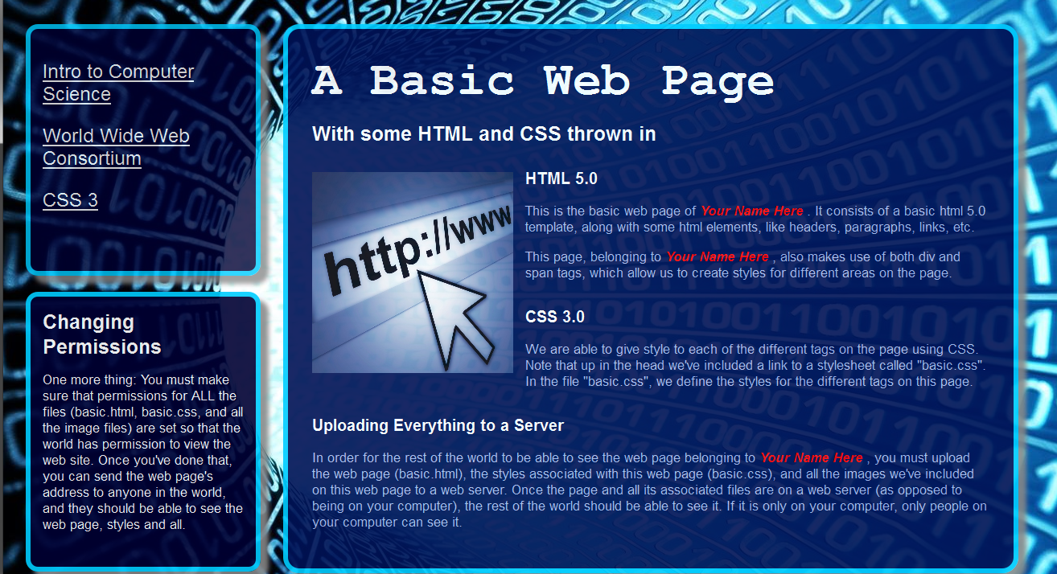

## To turn in:

Upload your web site’s url on Canvas under Lab1. It should look something like this:

[http:// udel.edu/~yourname](http://copland.udel.edu/~yourname)/lab1/basic1.html

If the URL looks something like this:

<file:///C:/Users/>...

It is not the correct URL. That is the location of the web site on your computer. Your TA cannot see what is on your computer. S/He can only see things on the server, and those URL addresses should start with http: and have udel.edu in them somewhere.