Dreamweaver CS6 Lab 2

Using an External Style Sheet in Dreamweaver

Creating the site definition
First, we'll set up the site and define it so that Dreamweaver understands the site structure for your project. You’ve already done this in the previous lab, so if you hit problems, refer to the last Dreamweaver lab.
- Download and unzip bmw-samples.zip provided on my web site.
- Store everything on your flash drive.
First, on your flash drive (or in a location you can access easily), create a folder called DWLab2. Go inside DWLab2 and create 2 folders called ImagesLab2 and CSSFiles. Place all images downloaded from my Web site in ImagesLab2.
Open Dreamweaver.
- Under the Site menu window at the top, click on New Site
- Name your site DWLab2
- Change the Local Site Folder to your DWLab2 on your flash drive.
- Click on Advanced Settings (on the right) -> Local Info
- Under Default images folder, select DWLab2/ImagesLab2. (Click on Select)
- Hit Save.

Linking to an External Style Sheet
By using an external (linked) style sheet, you can easily control and update the appearance of every page in your site that is linked to that CSS file. This is most powerful way to use CSS. By using a linked style sheet, you have the ability to make site wide changes on any number of pages by simply making changes in a single location. Major site updates can be completed in what may amount to no more than a few seconds' work.
- Select File > New or press Control-N to open the New Document dialog box,
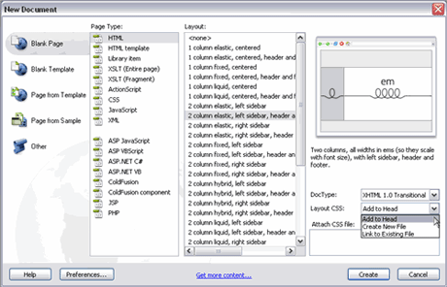
- Select the Blank Page option in the far left column.
- In the Page Type column, choose HTML.
- When HTML is selected as the page type, the Layout column to the right updates with an extensive list of layout options.
- Select the 2 column liquid, left sidebar, header and footer option.
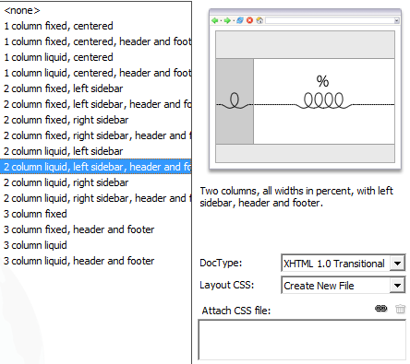
Notice that a visual display of the page is shown on the top right side, the looped lines indicate the layout’s flexibility. (Some of the other options display straight lines and padlocks to indicate that they are fixed width layouts).
You can select a DOCTYPE (you’ve seen this!) version from the DocType drop-down menu. For now, keep the default setting of XHTML 1.0 transitional (we used html5 in class).
The Layout CSS drop-down menu allows you to select how the layout you’ve selected will be added to your new page. Selecting the option Add to Head will embed the CSS styles directly into the new HTML document. The option Create New File lets you create a new external style sheet for this new HTML page. If you are working with an existing HTML page and want to add this new CSS layout code to it, choosing Link to Existing File lets you do this. It’s important to note that you also have the option to click the link icon next to the Attach CSS file option. This feature allows you to link this new CSS layout to another pre-existing style sheet.
- Select the Create New File option and then click Create.
- The Save Style Sheet File As dialog box appears. Navigate to your CssFiles folder and Save the Style Sheet file there (click on Save). The CSS file has been pre-named, and you should keep this default name as you save the file.
Next, save your HTML page in the root of your site's local root folder.
- Under the File dropdown menu, choose Save as.
- Navigate to your DWLab2 folder
- Name the file index.html.
- Hit Save.
Now that you've saved both your CSS and HTML files, it's time to take a look at the code in the HTML page.
Select the code view button and review the CSS content created by Dreamweaver CS6. 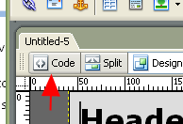
It should look like the code example below:
<link href="CssFiles/ twoColLiqLtHdr.css" rel="stylesheet" type="text/css" /><!--[if lte IE 7]>
<style>
.content { margin-right: -1px; } /* this 1px negative margin can be placed on any of the columns in this layout with the same corrective effect. */
ul.nav a { zoom: 1; } /* the zoom property gives IE the has Layout trigger it needs to correct extra whitespace between the links */
</style>
<![endif]-->
</head>

This layout will work well in the latest browsers, and the CSS also contains filters that allow the design to render successfully in older browsers, especially IE, as well. This is a huge time saver. Older browsers often don’t display things the same way as the latest browsers, and it’s nice not to have to worry about making sure your web page looks okay on browsers that haven’t been updated.
By the way, now you know how to see the code generated by Dreamweaver. Since you are now all experts at html, you can also edit the code created by Dreamweaver here. Don’t knock it – the ability to hand-edit your code comes in very handy when working in Dreamweaver!

Doc types
Dreamweaver adds a complete doc type to every web page you create. We did this with our web pages as well. An incomplete doc type can cause many problems when working with CSS.
An example of an inserted doc type is shown below. In this case, the code displays a Transitional XHTML doc type:
<!DOCTYPE html PUBLIC "-//W3C//DTD XHTML 1.0 Transitional//EN" "http://www.w3.org/TR/xhtml1/DTD/xhtml1-transitional.dtd">
We just did
<!DOCTYPE html>
In class, which is for html5. But remember, html 5 isn’t quite standard yet. Here we’re using transitional. Transitional means we’ll allow xhtml 1.0 and older versions of html as well.
<html xmlns="http://www.w3.org/1999/xhtml">
This is telling the browser where the standards are located for xhtml.
Again, with html, we just did
<html>
Working with XHTML pages that have an incomplete doc type will cause your browser to go into what is called "quirks mode". This will very quickly cause you to lose your hair and your sanity if you are aiming for a perfect, consistent design.
You should also be aware that if you put any text above the doc type—even a comment—and you viewed the page in Internet Explorer, the browser would go into quirks mode .
- To get back to viewing the page in Design mode, click on the Design button (to the right of the Code button).

Accessibility Issues
Each element provided in the HTML specification is designed for a specific purpose and each element has a specific meaning. An <h1> element is an example of a header. A screenreader recognizes text that exists between header tags as a header (or title), just as text within <p> tags is recognized as a paragraph. However, not all tags are semantic in their makeup. Screenreaders are software programs used by those who are blind or visually impaired to read the content of a web page to the user.
Take the <div> tag, for instance. A <div> tag has no implied meaning associated with it; it is simply a container element. The <div> tag can be useful for applying specific formatting to an element on the page, but it should only be used if there are no tags already available for that element. For example, if a <div> tag is placed around a header text and then styled to emphasize text within a div tag, it will render correctly in the browser, but it would be much better to use the <h1> tag for this purpose. This is what the <h1> tag was designed to do. When the screen reader encounters an <h1> tag, it knows that this text should be emphasized because it is a title, and shouldn’t be read as if it is regular text in a paragraph.
The header element you use depends on the location of the header in your document. For example, an <h1> tag should surround the main heading on your page. The next level of subheadings would be surrounded by <h2>, and so on. To screenreaders, <h1> is the most important header and <h6> is the least important header. Each level of header has a natural place within your documents. It is very important to set up your document in a hierarchical manner that is easily read by machine readers as well as humans. Using hierarchical structure to present your site content in an organized fashion will ensure that browsers and search engines can correctly navigate the elements on your page as well.
  - Defining Style Properties

Removing Default Properties and Values
Browsers apply default styles to elements (remember what your page looked like before you attached a style sheet?); unfortunately these default values are not consistent. These default values can, and do, vary greatly from browser to browser. With this in mind, we will create a CSS rule in our style sheet that will remove all the default values. It is a best practice to always "zero out" the default values, so that your page design is based on a standardized view, no matter which browser is used to view it.
To remove the default properties efficiently, we will group selectors together. By grouping the selectors, we can create a single CSS rule and use the wildcard selector to zero off all the default values. The wildcard selector is denoted with the asterisk symbol: *. The wildcard means "all"—which is a powerful way to refer to all page elements (body, etc.) at once. Remember that the order in which you list the rules in your style sheet is very important. The rule to remove the default values and start your design from a "zeroed out" space should always be the first rule in your CSS page. You could encounter odd display issues if the rule was placed below other rules, because when the browser "reads" the rule it would zero out all of the padding and margin values that were set in the rules that preceded it in the style sheet.
Let’s get started.
- Make sure you are working with the CSS style sheet: twoColElsLtHdr.css 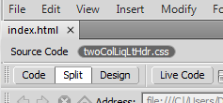
- Place your cursor at the very top of your style sheet right below @charset "utf-8"; and press Enter twice to make room for the new CSS rule.
- Type the following:
{
margin: 0px;
padding: 0px;
border:0px;
}
This rule deletes the margin and padding values that already exist in some browsers, ensuring that the page is displayed using only the values set in the CSS rules that follow this rule. This is especially important for older browsers.
- Save the CSS page
- Click on the Design tab to close the CSS stylesheet and view the design.
It is highly recommended that you add this rule to any new CSS page you create, because it is very helpful in eliminating issues that you may encounter when troubleshooting the display of your page layouts.
Once removed, we can begin the next task: adding specific values for the margin and padding for each element, to set the desired spacing.
To achieve this goal, we’ll use the interface within Dreamweaver CS6, specifically the CSS Panel and we’ll edit the index.html page while working in Design view in the Document window.
twoColElstHdr.css may already be attached to index.html as its style sheet. If it isn’t, do the following steps: 26-31
- Make sure the file index.html is active in the Design view of the Document window
- If CSS Styles isn’t visible (right bar), select Window > CSS Styles to open the CSS Styles panel
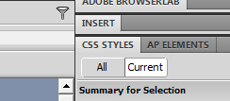
- Click on the Attach Style Sheet icon below CSS Styles (bottom right of CSS Styles).
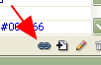
- In the popup window, navigate to twoColElstHdr.css.
- Make sure Link is selected.
- Hit OK. You’ve just attached an existing style sheet to your index.html.

- Click the New CSS Rule button

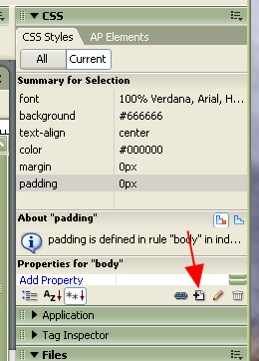
- In the New CSS Rule dialog box, select Tag as the Selector Type
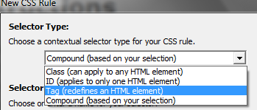

- Select p from the drop-down menu below the Selector name Tag field to select the <p> tag
- Ensure that twoColElstHdr.css is the file selected to define the <p> tag rule (at the bottom of the window)
- Click OK
- In the Category column, select Type (if it is not already selected)
- In the Font Size field, enter the value: 80
- In the drop-down menu immediately to the right of the Size field, select %
- Now select the Box option under Category
- In the Box option, under Margin, deselect Same for all
- In the margin field, next to top and bottom, enter 1.5 and em
- In the margin field, next right and left, enter 0 and ems
- Click OK.
You’ve now modified the Style in the CSS for the p tag.
- Click on the index.html file to refresh the display in Design view (it may have automatically updated the display for you). Notice how the page updates to reflect the new margin settings
- If you’d like to see the CSS rule generated by the changes made to the CSS Styles panel, look at the code in the twoColElsLtHdr.css file to see the new CSS rule for the <p> tag. (Scroll to the bottom) It will look like this:
p {
font-size: 80%;
margin-top: 1.5em;
margin-right: 0em;
margin-bottom: 1.5em;
margin-left: 0em;
}
- Save the twoColElsLtHdr.css file
Using the em measurement setting ensures that the various elements on your page will scale proportionately.

Inheritance and specificity
Now we’ve created a CSS rule for the <p> tag element to define both the text size and the margins that surround text that is inside <p> tags. As you know, when a CSS style is set, it will affect the element itself, as well as any other page elements within it. In this case, the <p> tag surrounds all of the text elements on the index.html page, causing the text to display differently when different values are set.
Let’s examine how inheritance works.
- At the top of the CSS Styles panel, click the All button to see all the styles.
- If the list below shows only twoColElsLtHdr.css, click the arrow to the left to expand the list of styles.
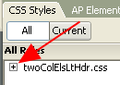
- Select the body rule by clicking on ---body
- The properties section of the CSS Styles panel updates to show the values of the body rule.
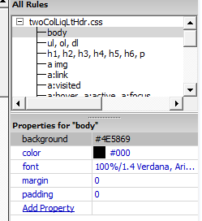
- Click the Color Picker next to the Color property. Select a reddish color.
Notice that the text content in index.html is now displayed in red.
In this example of inheritance, the text in the p tags (the paragraphs) as well as text inside any other tag is inheriting its color value from the body property. If you look at the CSS Styles panel again, you’ll see the body has its font property set to 100% Verdana, Arial, Helvetica, sans-serif. Since the body surrounds all of the other elements on the page, changes made to the CSS rule for the body will cause all other elements to inherit the same styles throughout the page.
- Select the Color Picker again and select black.
- All of the text now returns to black.
- Select the P rule in the CSS Styles panel (you may need to scroll down).
- If closed, expand the font section by clicking the plus sign (+).
- Click Add Property
- Scroll down to color
- Click the Color Picker next to the Color property. Select a blue color.
- All of the text that exists within p elements is now displayed in blue.
- Notice that all other text not surrounded by <p> tags remains black.
- Change your p element text back to black
- Save the CSS page.
In the example above, we’ve seen that when you add a color specifically to the p element, it overrides the inherited color of black that was applied to the body rule. This is the basis of specificity, where the CSS rule applied to a tag that is most specific to a page element overrides the inherited values of other CSS rules. In this case, the color setting on the p rule is more specific to the text than the color setting on the body rule. That is why settings made to the p tag override the inherited settings of the body tag.

Scaling font sizes
In the previous exercises, we added a CSS rule for the p tag with a font-size of 80% for text display. The CSS rule for p is stating that the text should be 80% of the default font size. Since the body is set to 100%, this means the text display of the font-size is rendered as 80% of the default size, or 80% of 100%. If you change the default font-size on the body rule to 200%, the 80% you set on the p rule increases in size proportionally. Now let’s modify the headers on the page. At the moment, they look a little too big for the page, because we’ve scaled down the font size of the p element. Let’s fix this by setting specific font sizes for each of the headers.
- Click the text in the Main Content heading to select the <h1> header. (Instructions) – you can double-click on it to select the entire word and triple-click to select the the entire title.
- Click the New CSS Rule button.
- The New CSS Rule dialog appears. In the Selector Type choose Tag (redefines an HTML element). The Selector field should already hold the <h1> tag.
- Double-check that the field next to Rule Definition: contains the CSS file twoColElsLtHdr.css.
- Click OK.
- In the CSS Rule Definition dialog box, enter the following value into the Font-size field: 150.
- In the drop-down menu to the right, select %.
- Click OK.
The Main Content heading updates and its size is scaled in relation to the default size set in the CSS rule for the body.
- Save the CSS page. You may need to select twoColLiqLtHdr.css tab first. Notice that it should have an asterisk next to it. That means it has changes that haven’t been saved.
Repeat this process for each of the remaining headings, using the values shown below:
- Set the <h1> tag in the header (text = Header) to 150%
- Set the <h2> tag in the lower content area (text = H2 level heading) to 125%
- Set the <h3> tag in the sidebar (text = sidebar1 Content) to 115%

Grouping selectors
Grouping selectors is an ideal way to avoid writing repetitive styles. So far we’ve set CSS rules for three of the six available heading options; we’ve not yet specified the font sizes for h4, h5 or h6. It is likely that we’ll want to use these elements in our design at some point in the future, so let’s set the size for them now. Since we want all of the headers to display at the same size, we can create a CSS rule that uses a grouped selector to hold the property and value. In this example, we’ll set the font size of all three headers to 105%.
h4, h5, h6 {
font-size: 105%
}
We’ll do that now:
- Click the New CSS Rule button.
- In the New CSS Rule dialog box, Select Compound (based on your selection) in Selector Type and delete the contents of the Selector Name (just click on it and hit backspace).
- Type: h4, h5, h6 into the Selector text field, (note the commas and spaces).
- Double check that the twoColElsLtHdr.css is selected in the Define in: field.
- Click OK.
- In the CSS Rule Definition dialog box, enter the following value into the size field: 105.
- In the drop-down menu to the right, select %.
- Click OK.
- Look at the new rule in the style sheet.
- Save the CSS page.

Working with floats
The float property allows you to move a floated element either to the right or to the left within its parent container. It is likely you will (and have) used the float property frequently when designing CSS layouts. Let's start by examining how to float images within a p element. It is a common practice to set up two generic float classes. One class floats elements to the left; the other floats them to the right. When you use Dreamweaver to create your CSS layout, the code generated looks like the examples below.
.fltrt {
/* this class can be used whenever you wish to float an element to the right side of the page. The floated element must be placed above the element that will display next to it in the source code. */
float: right;
margin-left: 8px;
}

.fltlft {
/* this class can be used whenever you wish to float an element left on the page */
float: left;
margin-right: 8px;
}
From the files from my Web site you unzipped, inside the images folder you’ll find an image file called bmw.jpg. This image of a car will be used to demonstrate how images can be floated to the left and the right within a container (the p element).
- In Dreamweaver, make sure index.html is in the Design view.
- Place your cursor immediately to the left of the first letter of the top section in your main content area, right before the paragraph of text below the Main Content header (to the left of Be aware…).
- Select the Insert->Image menu at the top
- In the Select Image Source dialog box, navigate to the images folder. Select bmw.jpg.
- In the Image Accessibility Attributes dialog box, enter a short description into the Alternate text field, such as “Front picture of BMW”.
- Click OK.
The image is inserted into your page.
- Make sure the image is selected (if it isn’t, click on it in the Design View).
- Next to Class (in the Properties area, usually at the bottom) In the drop-down menu, choose fltrt.
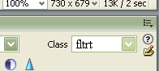
Note that the image moves to the right side, and the text flows around it.
- Repeat this process to add bmw2.jpg to the lower content area (below H2 level heading, next to “Because all columns…”), but this time select Set Class > fltlft.
Note that the image moves to the left side, and the text displays to the right of it.
- Save your HTML page.
Remember, when you float an element, you are effectively removing it from the document flow. This allows the other elements on the page that are placed directly below to move up alongside and when possible flow around the floated element. Applying the float class to an image allows the text to flow around the image.

Setting the image and changing the header’s background color
- Click on the Insert_Logo box at the top left of the web page. Make sure the box (there’s a yellow line around it) is selected:
- Double-click on it.
- From the Insert pop-up box, select bmwHeader.jpg
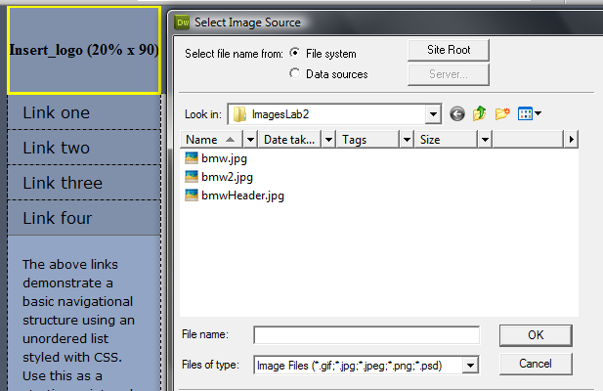
- In the Image Tag Accessibility dialog box, add the alt text for the header image (bmw header).
  - If this doesn’t come up, you can always add an Alt tag in the properties dialog box, at the bottom of DW.
- Click OK
The image is now inserted in the header area of the page.
- In the CSS Styles panel, select .header.
- Underneath, where the Properties are displayed, click on Add Property and select background-color.
- Click the color chip to select a background color
- Use the eyedropper – run it over the background color at the right of the BMW-header photo.
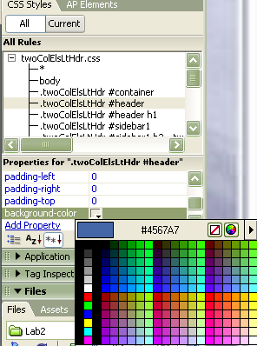
- After making this selection, the header div displays as the same blue as the BMW background color
- In the CSS Styles panel, Click on Add Property and select the Border-bottom-color property
- Add a bottom border to the header div by selecting the bottom border color using the color cube. Select black.
- Click Add Property and select Border-bottom-style.
- Choose the solid option.
- Click Add Property and select Border-bottom-width.
- Select the thin option.
- Click on index.htm in Design view to refresh the page content.
The header div element displays the bottom border based on the applied settings
- Save the CSS file.
- Choose File > Preview in Browser to review your work.

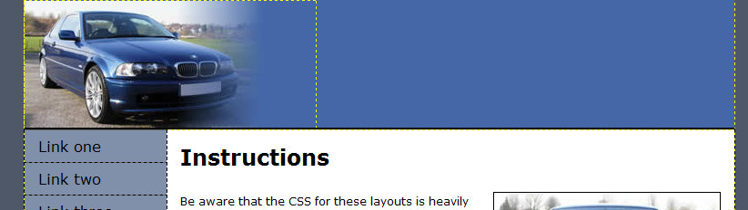

Styling the main content
Let’s style the main content. First, we’ll focus on the sidebar element content and adding the navigation bar.
- Set the Document window to Design view, if it is not already.
- In the CSS Styles panel, click the All button to see all styles.
- Select the CSS rule for the element in . container
- Below, in the Properties area, select Add Property and select the margin-top
- In the drop-down menu next to width, enter: 1.
- As the unit of measurement, select ems
- Select Add Property and select color.
- Use the eyedropper tool to select a dark gray / blue color. I used a hex value of: #393B4A.
- Select the P rule listed in the CSS Styles panel
- Click the color cube to access the eyedropper tool. Select a color from the h1 color.
- Adjust the color to display P elements, to make them lighter
- By lightening the P element color, you ensure that the headings are always darker than the main content text.
- Save the CSS file.
We’ve now completed the styling for the header and the main content area.

Building a vertical unordered list navigation
At the moment, the sidebar1 div holds some default content; this content consists of a heading followed by three links in paragraph text content. First, we’ll remove the paragraph text. You can complete this task by following the steps below:
- Click and drag over the text below the Sidebar1 Content heading (Below Link four)
- Press the delete key.
- The paragraph text is removed from the page design.
- Repeat the above steps and remove the second paragraph
After you’ve removed the placeholder content in the sidebar1 Content div you are ready to begin building your site navigation.
- Select Link one in the sidebar by double-clicking on it
- If it’s not still open, Open the CSS Styles panel by selecting Window > Styles.
- Click the New CSS style button.
- Dreamweaver has created the descendant selector for you - .container .sidebar1 .nav li a. (Go with the defaults this time) It is displayed in the Selector text field.
- Make sure the menu option for Define in: twoColElsLtHdr.css
- Click OK.
- In the Category column, select Type.
- In the text field next to Font Size: type: 80
- In the drop-down menu next to Size: select %.
- Click OK.
- The page design updates to reflect the recent changes
Next, we’ll add a little left margin to the li elements, to move the navigation away from the edge of the page and give the design some breathing room.
- Select the first linked text item, (Link 1) if not still selected.
- In the Property inspector, type the number sign (#) into the Link field. Hit Return. (Note that you could type in a url here instead of #. For now, we’re using # to make temporary links that go nowhere.)
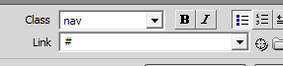
- Repeat steps 1 and 2 twice, for Link 2 and Link 3 and Link 4 (Note: this may be the default)
- Click the cursor inside one of the link items on the page.
- Click the New CSS Rule button.
- Make sure .container .sidebar1 .nav li a is selected and Define in: twoColElsLtHdr.css are selected and hit OK.
- Select the Type option from the Category column.
- Click the Color Picker cube.
- Select the blue header background color using the eyedropper tool in the Color Picker.
- In the Text-Decoration option, select none.
- Select the Box option from the category column.
- Deselect the "Same for all" option in the Margin section.
- In the right field, type 1.
- In the margin-left text box, type: 1
- In the adjacent drop-down menus, select em.
- In the padding option text field, type: 2 and px. This will add 2 px to all 4 sides.
- Deselect Same for all option for Padding.
- Next to Right, select 60
- In the adjacent drop-down menu, select px.
- Select the Background option
- Click the Background Color Picker cube.
- Select the hexadecimal value #FFFFCC (shorthanded with #FFC) (a pale yellow color).
- Click OK
- Save index.html and the CSS style sheet.
We created the basis for our navigation; we’ve added the text that will be used for the links. Next, we’ll change the text into navigation links.
Now that we’ve created a style for the linked text in the navigation bar, we’ll add a hover effect that will interact with the users cursor when they run their mouse over the links.
- Click the cursor inside one of the links in the sidebar1 div.
- In the CSS Styles panel, click the New CSS Rule button.
- In the New CSS Rule dialog box, by the Selector Name click to the right of the a element
- In the Selector text field, type :hover with no space after the a element. It should look like this:
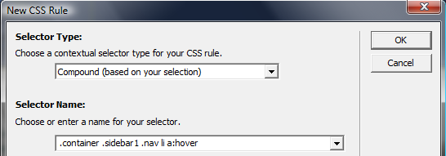
- Make sure your CSS style sheet is selected in the Rule Definition drop-down menu.
- Click OK.
- In the CSS Rule Definition box, select Type from the Category column.
- Click the Color Picker cube and select the hexadecimal value #000000 (or #000) (black).
- Select the Background option from the Category column.
- Set the background color to the hexadecimal value #CCCCCC (or #CCC).
- Click OK
- Save the CSS style sheet.
- Press F12 to view the index.html page in a browser. Test the navigation buttons by rolling your cursor over the linked text to check the rollover effects.
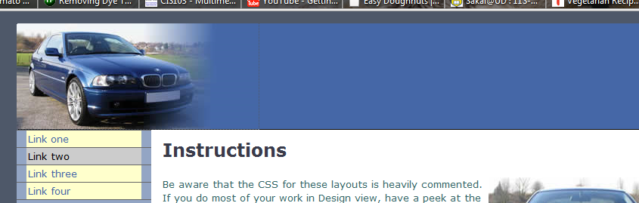
The navigation system for the sample site is now complete.
Let’s make the sidebar yellow to match the navigation.
- Click on the sidebar to the left of link one.
- Click on the edge of the sidebar until it is selected. Very carefully run your pointer over it. You should get a pop-up box like this:
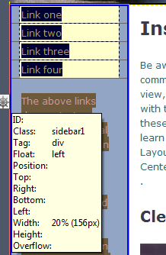
- Now you know that the whole side area belongs to a div with the class of “sidebar1”.
- Over under CSS Styles, scroll down until you find sidebar1.
- 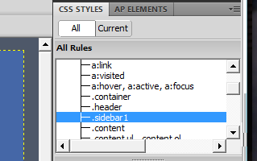
- Underneath, click Add Property
- Select background-color
- Change the background color to #FFFFCC (or #FFC)
- Save.
- Preview in browser.
You’re done! You’ve just created a Web page in Dreamweaver using your own stylesheet! Stylesheets take a bit of getting used to, but with practice they become easier and make managing Web sites simple.

To turn in:

DWLab2 Folder containing the

ImagesLab2 and CSSFiles Folders containing:

CSSIndex.html

twoColElsLtHdr.css

The three downloaded images

