Introduction to Dreamweaver

# Dreamweaver – what is it?

Adobe Dreamweaver is a software application that allows you to create and develop Web sites. Dreamweaver is considered WYSIWYG (What You See Is What You Get), meaning that when you format your Web page, you see the results of the formatting instead of the mark-ups that are used for formatting. HTML is not WYSIWYG, whereas Microsoft Word is WYSIWYG. However, Dreamweaver allows you to hand code HTML as well. Dreamweaver also supports CSS and JavaScript as well as other languages including ASP and PHP.

Dreamweaver makes it easy to upload your entire Web site to a Web server. You can also preview your site locally. Dreamweaver also lets you create templates for your Web site that you can use again and again by modifying certain unrestricted areas within the template. Then if you want to change one particular part of your Web site (the logo changes, a main link changes), you only have to modify the template for the changes to propagate throughout your Web site.

Dreamweaver is fairly complex software. In this lab we will be getting a basic introduction to this software package.

Using Dreamweaver

Dreamweaver is a web authoring program that uses a WYSIWYG “what you see is what you get” interface. The HTML code is being created and is accessible to you if you want to play with it.

1. Start Dreamweaver. You should see a startup screen.

Dreamweaver lets you publish your Web site by easily uploading your Web site to a Web server. Right now we won’t be worrying about that. For now, you will be creating and viewing your site locally (which means the site will be located on your computer).

We need to define your site:

# Create a New Site

1. From the Site menu, choose HTML under Create New.

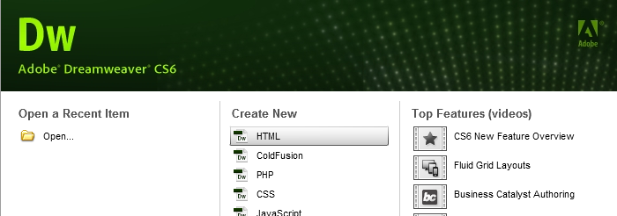

# Making your first Web Page:

1. You should now see a blank Web page in the Document Window.
2. Under the File Menu (top left of Dreamweaver work area), choose Save.
3. In the Save As box, find your Web site folder and save your file as index.html
4. Click Save. Congratulations! You’ve created your first Web page using Dreamweaver. Unfortunately, it’s pretty boring at the moment.

RULES OF THUMB for naming web files:

• Do not use spaces or special characters, such as those found above the number keys on the keyboard, in your file names. You can use dashes and underscores. (e.g., my_page.html)

• Always use a 3- or 4-character file extension for every file you use on the Web. In the case of a regular Web page, always use .htm or .html.

• Be very specific about capitalizing because **most Web servers are case-sensitive**.

# Give your Web Page a Title

In the document toolbar, find the Title box.

1. On the document toolbar (across top of Dreamweaver work area), locate the **Title** field.



1. Type in a title for your page. Feel free to be creative (but not indecent). Hit Enter.
2. The title doesn’t show up on the page, but will appear in tabs and across the top of browsers.

Adding Some Content Add Content to the Page

1. If you’ve got Split selected (right above the work area but below the top menus), you should have a split screen – the left half will be your html code and the right half will be a blank document window. You can always elect to click on the code button to just view code, or the design button to just see what your design will look like. For now, work on the right side in the document window. In this right document window, type in a good head title. This one will be the head title at the top of your Web page. If you can’t think of anything, you can always use, “Aardvark Adoption Society of Delaware”.
2. Add a subtitle below it. Again, it can be anything you want. If you’d prefer, it could be, “We speak for Aardvarks who can’t speak for themselves.”
3. If you still have split screen, notice how Dreamweaver automatically puts html tags around the text we’ve typed in. It’s not what we want – we’ll change that shortly.
4. Now that you’ve got a good title, add some content. Logically, it should go with the title. Type one or two lines now for now. We’ll add more later. If you like, I’ve included some content on my web site about Aardvark adoption that you can use. If you copy and paste the content, again, notice that Dreamweaver automatically puts html tags around the text we’ve copied and pasted. We will be changing most of those tags below.

Now let’s format the content:

1. In the document window, highlight the header title.
2. In the Property Inspector (usually at the bottom), click on the Format drop down arrow, and choose Heading 1.



*Note: If you do not see the Property Inspector, in the menu across the top choose Window >> Properties.*

1. In the document window, highlight “We speak for aardvarks…”.
2. From the Format menu on the Property Inspector, choose Heading 2.

Note: When formatting your text, keep in mind that text sizes in HTML are relative sizes. This means that, when your page is viewed in a browser, the text size will depend on the default text size settings on each user’s computer. Relative sizes give users the ability to adjust the text size to suit their individual needs. This option is especially important for people with visual impairments, but it means that the appearance of your pages may vary from computer to computer.

## Playing with Font Properties

1. Highlight the Subtitle (We speak for Aardvarks…).
2. Make sure the CSS is selected in the properties pane Change the font size to 24.

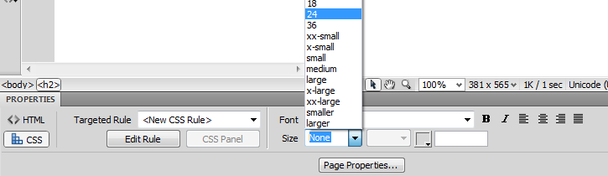.

1. You’ll get a window telling you to create a New CSS Rule. Under Selector Type choose Tag (redefines an HTML element)

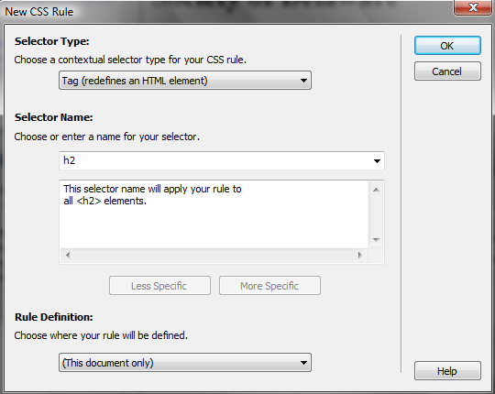

1. Hit OK

(If you still have your code window pane open on the left, you can see the style added in the head section of your html code).

1. With “We speak for Aardvarks…” still highlighted, click the Bold icon ( ) in the Property Inspector. The selected word appears bold.
2. Click the gray square to the right of the Size popup menu in the Property Inspector. A grid of colored squares appears, and the cursor changes to an eye dropper.



1. Click the eyedropper on the desired color.The field to the right of the color swatch reflects the code Web browsers need to correctly display the color you’ve chosen.



*(Note – if the CSS pop-up box appears again, just select Tag again)*

1. Click anywhere on the page to deselect the text. The previously selected text appears in the new color.

## Alignment

1. With “We Speak for Aardvarks…” selected on the page, click on Align Center button on the Property Inspector. The subtitle (h2) should now be centered on your page.



1. Select the head title (“Aardvark Adoption Society of Delaware) and choose Align Center. You’ll get the New CSS Rule pop-up window. Make sure Tag is selected (the tag should be h1) and click OK. You should now have 2 rules in the head section of your html code. Feel free to play with color and size of h1 as well.

## Creating Lists

1. First we need to add a list.
2. Type in a title for your list and then type in a list of items. Make sure there are at least 3 items in your list. Make sure you hit return after each item. (Feel free to use a list from the aardvark content if you can’t think of your own. I used the list titled “Specifically, we need…”
3. Highlight the list title and choose Heading 3 from the Format menu on the Property Inspector (Make sure HTML is selected, not CSS).
4. Highlight the list items and click the Unordered List button on the Property Inspector.



1. The items appear as a bulletedlist.
2. Now type in another List title and another list of items, or use the one within the content on the web page. (I used the one titled, “Please note the following rules”).
3. Highlight the title and select Heading 3 (Note: if using copied code, you may need to put the title on a separate line by hitting the enter button)
4. Highlight the rest of the items and click the Ordered Listbutton on the Property inspector (next to the ordered list button). The items should now appear in a numberedlist.
5. Save your work. Get into the habit of saving your work regularly.

## Page Properties

In this section you will learn how to set your page’s background color, as well as the default text and link colors. These settings differ from what you’ve done so far on the Property Inspector because they’ll apply to all the text and links on the page—not just a selected piece of text.

1. From the Modify menu at the top of the workspace, choose Page Properties.

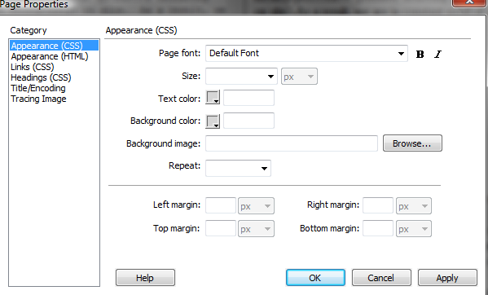

1. Change the text color by clicking the bottom right corner of the text color box.
2. Using the eyedropper, choose a color by clicking on any of the color swatches.
3. Similarly, Change the background color for the page using the Background color setting.

You can also change the color of links, active links, and visited links. An active link is a link just when the user clicks it. A color change lets the user know that s/he clicked on a link. A visited link is one that the user has already clicked on and visited. A color change lets the user know s/he’s already visited that link.

1. Select “Links (CSS)” from the Category menu at left, then make your selections for link, visited link, and active link colors as you did above.

Note that if you click on Headings from the Category menu on the left, you will see the basic modifications you’ve made to h1 and h2.

1. Click the Apply button to see how your color choices look on the index page. The Page Properties dialog box will remain on the screen.
2. When you’re satisfied with the colors you’ve picked, click OK.

Note: *You can add a background image if you want. With Appearance (CSS) selected, locate Background image: To the right, Browse to find an image by the background image. See what it looks like. Now you know that’s an option. We’ll talk about this option more later. For now, go back to a solid color background.*

Note: *If you changed the color for any text using the Property Inspector, those changes will override general page color choices.*

## Web Page Preview

As you create a page in Dreamweaver, the page may not look exactly like it would in a browser. To preview the page in a browser:

1. Choose File >> Preview in Browser >> Firefox or press the F12 key (F12 brings up the page in your default browser). A web browser, such as Firefox, opens and loads the web page.
2. Take a look at your page to see how it will appear on the Web.
3. When finished, close the browser and switch back to Dreamweaver.

NOTE: *Colored or underlined text can be mistaken for links.*

## Adding Images

Note: Any editing or resizing of an image should be completed **before** it is added to a web page. Browsers aren’t designed to resize images, and they do a poor job of it.

1. First you need an image. Feel free to find one on your own that suits the theme of your web page, or use the Aardvark images I’ve included on my web page.
2. Save the files to the same place where you are saving the index.html page you are creating in Dreamweaver.
3. Next, add it to your Web page.
4. Place your cursor below the h2 (“We speak for Aardvarks…”) in your document and press Enter twice.
5. From the menu panel across the top, choose Insert >> Image. The Select Image Source dialog box will appear.
6. Using the dialog box, locate and select an image, then click OK.
7. You will first encounter a prompt to add accessibility attributes:



1. Type a brief description of the image in the Alternate text box, then click OK.
2. If you’re trying to use a file that lies outside your root folder (mywebsite), you may receive the following message:



* 1. Click Yes. The Copy File As dialog box will appear.
  2. Click the Save button to place a copy of the image file inside your my website folder.

1. The image will appear on your web page.
2. Make sure your files panel is visible. The files panel is located in the lower right corner. If you don’t see it, click on the files tab at the very bottom of the right sidebar. It holds a menu of the files you are currently working on and all files in that directory.



## Delete an Image

1. In the Document window, click on the image to select the image.
2. Press the Delete key. The image disappears.
3. To reverse the deletion, use the Undo command. From the Edit menu in the top menu panel, choose Undo. The image should re-appear on the page.

## Create a Second Page

Next, you will create a second page for your Web site.

1. From the File menu, choose New…The New page dialog box appears.
2. Make sure Blank Page -> HTML -> <none> is selected.
3. Under DocType, select HTML 5
4. Click the Create button. The new file will appear in the document window.
5. Save your new page in the mywebsite folder as Page2.html
6. In the Title field, type an appropriate title for this page. We’ll eventually make it into a Calendar of Events Page, if that helps you decide on a title.
7. Save your work.

# Page Navigation

Now that we have two pages, you can link them together. We’ll link the index.html page to the Page2.html and vice versa. It’s easy in Dreamweaver!

1. Use the tabs on the Document toolbar to toggle back to the index page.

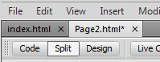

1. On the index page, type some descriptive text that describes your Page2.html.
2. Highlight the text you want to make a link.
3. In the Property Inspector, click on the Browse for File icon to the right of the link box. A Select File dialog box appears.

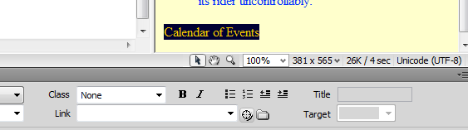

1. Using the dialog box, locate and select the file Page2.html.

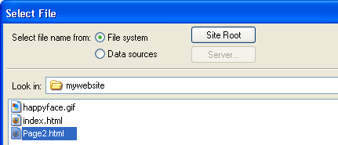

1. Click the OK button. Cool! You just made a link!
2. The selected linked text is underlined and appears in the link color you chose. In the Property Inspector, the Link field reads: “Page2.html
3. Save your work and preview the page in a browser.
4. Test the link. When finished, return to Dreamweaver.
5. Now, try linking Page2.html back to the index page.
6. Save your work and test the new link in a browser.

Next let’s add an absolute (external) link. By that I mean let’s link to a Web page that is located somewhere on the World Wide Web. We’ll need to use the full (absolute) URL to link to this page.

1. Go to the bottom of your index.html page and type “Links”. (or use the copied text)
2. Highlight the text you just typed.
3. In the Link box in the Property Inspector, type <http://en.wikipedia.org/wiki/Aardvark/> and press Enter.

Aardvarklink.bmp

1. The text you selected should now link to Wikipedia’s web page on Aardvarks. To make sure the link works properly, preview the page in a browser.
2. Switch back to Dreamweaver to continue editing your page.

## Add an E-mail Link

Now you’ll make your e-mail address a link so that visitors can send you questions and comments via email.

1. At the bottom of your page, type “Send us an email” and highlight the word email.
2. From the Insert menu across the top, choose Email Link. A pop-up box should appear.
3. Place your cursor in the E-mail box and type your email address:
4. Hit OK. Your e-mail address appears as a link.
5. Save your work. Please note that the email link will try to open a desktop email program if you have one on your computer. However, if the computer you’re working on doesn’t have an email program set up, testing this link won’t work.

## Creating a Link within a Page

### Create the Target of the link

1. Place your cursor at the top of your index.html page
2. Choose Insert >> Named Anchor.The Named Anchor dialog box will appear.
3. In the Anchor Name box, type a name for the anchor. This should describe the content in that section of the page.

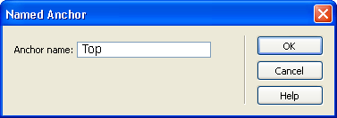

1. Click OK. A yellow anchor will appear just before the text.   
   (If the yellow anchor symbol does not appear, then choose **View >> Visual Aids >> Invisible Elements**.)

## Create a link to the anchor

1. At the bottom of the page, type “Back to Top”. Highlight this text.
2. On the Property Inspector, click on the point-to-fileicon to the right of the Link field. When clicking, hold down the mouse and drag it to the schedule anchor symbol. (Just click on it and, without releasing the mouse, drag it over the anchor symbol in your Web page. It may give you a bunch of black boxes. Ignore them).

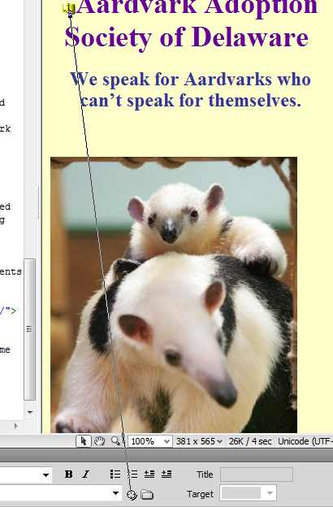

As the arrowhead moves over the anchor, the anchor name preceded by the pound sign (#) will appear in the link field. The selected text is now a link, and is underlined with a different text color.

The form that this type of link uses is different from a standard link. In the link field, a pound sign appears followed by the name of the anchor. The # (pound sign) indicates that the link is to an anchor on the Web page.

CSS to Paragraphs:

Let’s make this look a bit better:

1. Make sure CSS is selected in the bottom properties window.
2. In Targeted rule, select New CSS Rule
3. Click Edit Rule
4. In the pop-up window, under Selector Type, choose Tag, and under Selector name choose Bod (we’re modifying the style for the entire page.)
5. Select OK. The CSS Rule Definition pop-up box should pop up.
6. Under font-size, use the drop-down menu to choose medium.
7. Under line-height, choose 120, and then %
8. Choose OK

Try playing around with the CSS style for other content on the web page. Note that if you apply a style to one line and it affects all the lines above or below, you should first undo the change you made (under edit). Then go to the line you want to modify, and place your cursor before it. Hit Enter. Then place your cursor after it and hit enter again. This forces Dreamweaver to make that line a separate paragraph item. You can now highlight it and change its tag and style.

# Page Layout with Tables

We can use Tables to lay out the format of text and images. A table may be used for layout in a number of ways, including placing text or images side by side on a page. In this section, you’ll make a table that shows the Calendar dates and events for an Aardvark Sanctuary. a Table

1. Click on the Page2.html tab at the top of the Dreamweaver work space.
2. Place your cursor at the top of Page2.html after the text. Now, you’ll insert a table with 3 rows and 2 columns.
3. From the Insert menu, choose Table.The Table dialog box appears.
4. Under Table size, adjust the settings as follows:

**Rows = 3  
Columns = 2  
Table width = 75 %  
Border thickness = 1  
**

1. Click OK.The table will appear on your page.



1. Place your cursor in the upper-left cell of the table and type: “Schedule of Events”
2. On the second row, in the left-hand cell type: Date
3. Press the [Tab] key to move to the next cell in the table.
4. Type: Event
5. Press the [Tab] key again to move to the next row.
6. Type in a date. Move to the next cell, and type in a description of an event.As you type in a long paragraph, the words wrap within a cell.  
   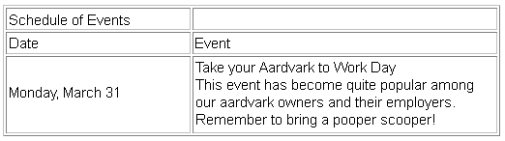
7. Press the TAB key, and a new row is automatically added to the table. Enter the date and event description in the fourth row.

## Merge Cells

We want the Schedule of Events to be centered across the entire table. To do that, we first need to merge the two top cells in the table.

1. Click and drag your cursor from left to right across row 1. You’ll now merge those two cells into one.
2. Choose Modify >> Table >> Merge Cells. Now, in row 1, you should see one large cell.

## Insert an Image

1. Place your cursor in the right-hand cell of the last row. Press the [Tab] key to add a new row.
2. Place your cursor in the right-hand cell of that new row. Choose Insert >> Image. The Select Image Source dialog box appears.
3. Navigate to an image – either one you’ve downloaded or one from my Web site that you can download.
4. Click OK. The image you chose will appear in the table cell.

## Add a new row to the table.

After you have created a table, you may need to add information in the middle of the table. You can add rows or columns to expand the table.

1. Click in the third row of your table.
2. Choose Modify >> Table **>>** Insert Row.

A new row appears in the table.

1. Click in the second column of the new row and insert another image (your choice). The image appears in the cell.
2. Click in the cell to the left of the image and type some relevant information in the cell.

## Delete a row

The table can also be adjusted by removing unnecessary rows or columns.

1. Click in the second row of your table.
2. From the Modify menu, choose Table, and then choose Delete Row. The row and its contents are delete.

## Resize columns and rows

Depending on the content you add to your table you might find that columns are too wide or narrow. You can adjust the column width to better fit the content in your table.

1. Place the cursor over the line dividing the columns.The cursor turns into a two-headed arrow.
2. Click and drag the two-headed arrow toward the right to the middle of the table.The columns are re-sized. (Note – if your images are too big, you may be unable to reposition the column widths.
3. Place the cursor over the right side of the table. Click and drag the two-headed arrow to re-sizethe table again.
4. Save and preview the page.

Try changing the size of the browser window. Notice that the table size changes as the browser window size changes – why? The reason the table size is not constant is because the width of the table is expressed as a *percentage* of the total width of the browser window, in this case, 75%. If you wish to lock the table to a specific size, you have to express the table dimensions differently.

Table dimensions can also be expressed as *fixed* using “pixels”. Screens are divided into thousands (or millions) of pixels, arranged in rows and columns. On a Web page, a recommended pixel size for a table’s width would be no higher than 800. (Assuming a screen width of 1024 to be safe).

When your table is selected, you can view and change the table width on the Property Inspector (as shown below).



## Experiment with cell color and other options

1. To add background shading to a cell or row, select the cell(s) and click on the bottom corner of the Bgcolor box on the Property Inspector
2. Click on a swatch with the eyedropper to choose a color.



1. Try various formatting options for the rest of the table using the Property Inspector. Change the **width**, **color** or **cellPadding and CellSpacing and Border**, and try the **Align** options.
2. Save your work and preview.

Congratulations. You have completed your introduction to Dreamweaver CS5. Of course, as usual, we’ve barely touched the potential of Dreamweaver.

# To turn in:

* Upload a folder containing:
  + The two html pages you created.
  + The images you included in your Web Site.