JS Lab 1
Due Thursday at midnight (35 pts)
NOTE: for the JS labs, you may work with a partner or work individually.
- (4 pts)Write an html page with a javascript that uses document.write to create a paragraph.
- (5 pts) Create a new javascript that has 2 variables: your first name in the first variable, and your last name in the second variable. Now use document.write to write a paragraph with, “Hi, my first name is Joe and my last name is Smith”, using your variables (replace Joe with your first name and Smith with your last name).
- (10pts)On the internet I found a chart about what your favorite candy says about you. It goes as follows:

Snickers -> you have a multi-faceted personality. You don’t fit into a box. You like to travel and read as much as TV and sports.
100 Grand -> you’re wise beyond your years. You were always the kind in class teachers were most in pressed with. You question things in a thoughtful way
MilkyWay-> you’re smooth! You know what to say and when to say it. You love a minimal, clean look. You enjoy cooking more than going out
3 Musketeers -> You’re a hero. You’re super humble and unassuming. You read long books
Butterfingers->you’re a little clumsy. You tend to lose stuff. Your favorite show is the Simpsons and you identify with Bart.
Candy Corn - >you probably need braces. You like cats.
Reese’s Peanut Butter Cups -> You’re a free spirit. You have a strong sense of self, and enjoy being around people who challenge you.
Smarties-> You’re the quiet, loving type. You treat everything with respect. You’re an introvert and you enjoy cooking with close friends.
Nerds -> You’re a total goofball. You might not always be funny, but everyone knows they’ll have a good time when you’re around. You’re weird in a good way. You’re probably a morning person.
Starbursts -> you’re the creative type. You like taking risks and stretching yourself in new, artistic fields. You like living near nature.
M&Ms ->you’re a model citizen. You always recycle. You’re always up for an adventure.
Kit Kat -> you’re cool, and super laid back. You go with the flow. You love traveling
Nestle crunch -> You’re a dreamer. You always have a positive attitude. You’re not too hard on yourself.
None of the above -> You’re picky. You know what you want and you are willing to wait to get it. Fine, but you’re missing out on a lot of good candy!
Write a javaScript that prompts the user, “what kind of candy do you like?” and then, based on what the user types in, prints out the candy they typed in as a header, and then a paragraph showing about their personality.
Note that no one is going to type in None of the above. That should be your final, catch-all else condition.

- (6 pts) Write a javaScript that generates a random number between 1 and 6. It uses that random number in a document.write to write a header of that size (e.g., <h1>,<h2>, etc.))
- (10 pts) Write a javaScript that generates a random number between 1 and 300 for the width. It then generates a second random number between 1 and 300 (for height). It then uses document.write to put an image on the web page, with the width being the random number generated for width, and the height being the random number generated for height.

Part 2:
For your final project, you will be working on a game. The exact nature of the game is up to you, but regardless you will need a setting for your game. Think about the theme of your game, and then start downloading images that will work with your game. I’m guessing you’ll need scenery, monsters, and a hero character. Start laying out your html and css to create an environment for your game. I’m including an image of my game. Your game doesn’t have to look anything like my game, but it gives you an idea of what I’m talking about.
NOTE: For part 2 you don’t have to turn anything in.

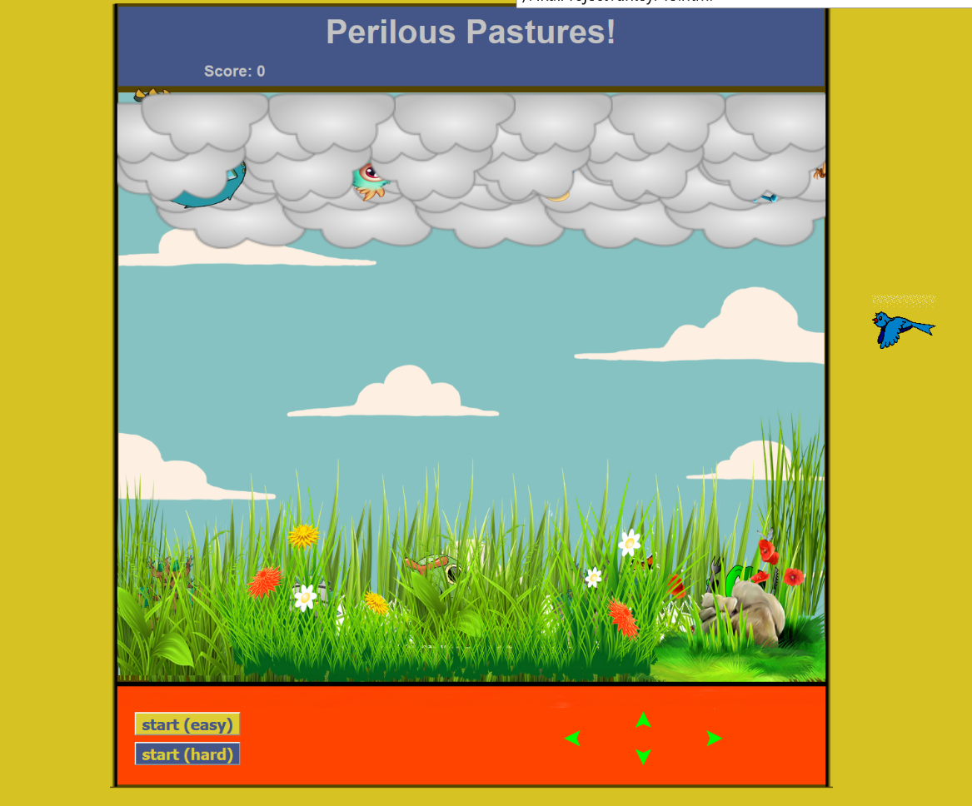
For this: my monsters are the scary creatures and the daffy wildlife. My hero is the bird. I’ve got a blue sky with moving clouds as a background (an animated gif), with a bunch of different cloud images positioned relatively and layered using the z-index at the top, and a bunch of different grass images positioned relatively and layered at the bottom, all placed relatively inside my table so that they overlap (and the scary creatures peeking out between the clouds and the grass). The layering is all done with z-indexing.

