Final Project
(50 pts, Due Monday, May 24)
You have the basic components of your final project completed if you have completed all the tutorials for the Final Lab. However, as you saw, it looked disjointed and not even remotely polished. Equally, there are many, many ways in which you could make the game more interesting, both visually and in terms of challenging.
Note: this final project should encompass everything we’ve learned throughout the entire semester!! So we’re finally really incorporating the html, css, and the javaScript! All of these thing together could be used for so many things- learning and training tools, user experience improvements, advertising, information gathering, etc. I’m using them for a game. Because.

To Start:

(25 pts) Appearance (mostly the html/css part):
Make the game look better. Position things appropriately. Give the game a color scheme and a background image (background images make a world of difference!). Make sure everything is sized to be proportional. Give the game a title. Maybe even give the game a border. I’m including a screen shot of my game after positioning and background image:
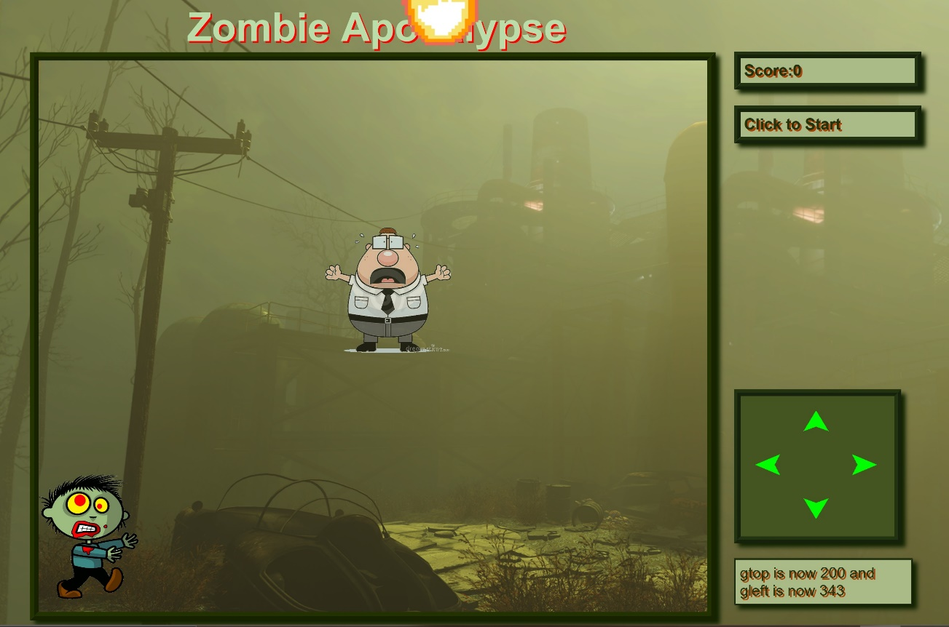

(25 pts) Additions (largely the JavaScript part):
For this game, I could think of many ways to make it more interesting, both visually and from a playing standpoint. I’m listing some of those below, along with point values. You can choose which of the following you want to add to your game, so that the total adds up to 50 pts (so you’ll need 25 points worth of additions, along with the 25 points for appearance). You can choose as many additions as you like to add up to 50 pts total. Equally, you may choose to implement up to 50 pts of extra credit.
- (5 pts)When the hero catches the goodie make the image change to something indicating that the goodie has been captured. (I made mine change to animated confetti, not because it had anything to do with the theme of the zombie apocalypse, but because I like it when I get confetti on my phone. It’s my game. I can do what I want!)
- (5 pts) When the hero gets killed, make the hero image change to something gruesome (Mine was a splat pic)
- (5 pts) Add a key that, when you hit it, calls a function that brings up an alert with the current score
- (5 pts) Make the background image change (or in some way change the scenery) when the hero wins ( the score === 10)
- (5 pts)Have the speed of the bad thing’s movement change randomly
- (10 pts) Have the speed of the goodie’s moving get faster as the game progresses
- (10 pts) Make the hero’s image change directions when the hero changes directions
- (10 pts) Limit the hero’s movements so he will stop moving if he gets to the end of the screen ( < 0 or greater than, maybe, 600, or whatever you set your screen size to be)
- (10 pts) Make the goodie’s picture change randomly to different goodies
- (10 pts) When the hero gets killed, make the goodie slowly fade to transparency
- (10 pts) Make the bad thing travel in more than one direction. Currently, it travels down from the top. Make it randomly travel from different directions
- (15 pts) Have multiple goodies, each worth a different number of points, and have the goal be to get a score of maybe 50 or something like that
- (15 pts) Make the goodies have different point values, and the bad things have point values, and if you get hit by a bad thing, make your score go down by the bad thing’s point value. If you go under 0, you lose
- (15 pts) Add a timing mechanism such that if the user doesn’t get so many points within a certain amount of time, the board resets and the user has to start over
- (15 pts) Add a mechanism that provides levels, with movements of the asteroid and the goodies being relatively slow at level 5 and much faster at level 1

Note: These are just a few ideas I’m throwing out. You very well may have much better ideas. If so, feel free to shoot them my way!!! I’m very willing to give points for creativity and effort!
I’ve included a video of my implementation of 1-9 and 11. Notice that I didn’t show you when I won. That didn’t happen very often. I think I need to slow down the movements of everything for me to win.
Have fun!!!

