Setting Up VPN Connection

We will be using***AnyConnect*** software for VPN connections.

1. Install **Google Authenticator**app on a mobile device**.**

**AnyConnect** uses**2FA** but a code will not be automatically sent to you.  You will need to use ***Google Authenticator*** to generate a code.  Download and install the **Google Authenticator** app from either the **Google Play**(Android) or **App Store** (Apple iOS devices) on your mobile device and follow these instructions .

2. Install ***AnyConnect*** software from UDeploy on your laptop or desktop.

From UDeploy - select the the [AnyConnect](https://udeploy.udel.edu/software/anyconnect-vpn/) software for your system.  **NOTE: If you are a Windows user, you MUST install this software using 'Run As Administrator'.** To do this right click on the downloaded file and choose this option.

3. Test your AnyConnect connection.

Find the AnyConnect app and open it.  The  icon should look like this:  

You should see a dialog box similar to this:

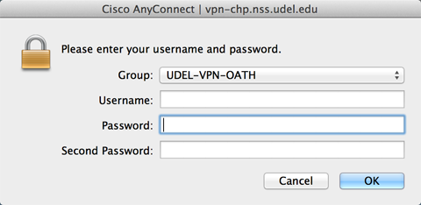

* + **Username:** Enter your udel email name (with or without @[udel.edu](http://udel.edu)) **NOTE: Do not use your numeric id.**
  + **Password:** Enter your udel password
  + **Second Password**:  6 digit code from Google Authenticator - open your Google Authenticator app on your mobile device and enter the most recent code

Click Ok - you should see a message that you are connected.