Installing Uploading Software

You must install software to upload web site files from your computer to the University’s web server. There are many programs available that allow you to do this. If you already have uploading software installed on your computer (e.g., fetch, winscp, etc.) you are welcome to use it.

However, if you do not, install cyberduck as follows.

1. Download cyberduck from: <https://cyberduck.io/>
2. Watch the following short video:

<https://help.hostedftp.com/help/cyberduck-tutorial-downloading-installing-understanding-cyberduck/>

Once you’ve installed cyberduck, you will log in to the University’s server as follows:

1. Click on the Open Connection Button

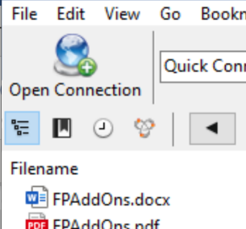

1. In the popup box that opens, add the following:
2. Make sure you select (SFTP) SSH File Transfer Protocol
3. Under Server: add copland.udel.edu
4. For username, use your username (your email, without the @udel.edu)
5. Add your password
6. Hit the Connect button

1. You should get something like this:

1. If you do not have a public_html folder, right click inside the big blank area with the files in it. Select New Folder. And inside “Enter the name for the new folder” type public_html (don’t forget the underscore!)

**Permissions:**

1. Click on the public_html folder to select it (don’t double click – you’re just selecting it here!)
2. At the top, select get info



1. At the top of the pop-up window, select Permissions

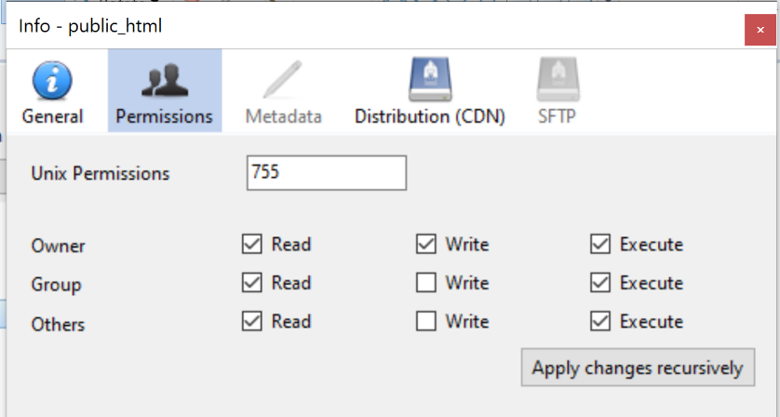

1. You’ll want to set your permissions as follows: under Unix Permissions, type 755

(Alternatively, Owner (you) should have read, write, and execute permission,   
group and Others should have read and execute permission

*Note: You don’t need to hit Apply changes recursively – the change is made automatically)*

**Uploading:**

**Note: If you’ve made it this far, you’ve set up cyberduck. The following instructions are for when you have files on your computer (e.g., web page files) that you want to upload to the web server.**

1. Double click (control-click )on public_html to go into that folder (all web stuff must go inside public_html.)
2. Now you can drag and drop files from your computer to the public_html folder
3. **Note:** You may need to change permissions on all files and folders you upload in order to be able to see them. Follow the instructions in steps 7-10 for each file and folder you upload. You can select multiple files at once and change permissions for all simultaneously.

**To see your web pages:**

1. Open a browser application as you normally do.
2. In the **Location** field, type the location of your home page, which will be similar to the following:

**http://udel.edu/~username/**

where **username** is your UDelNet ID (i.e., the name you use to log in to your UD e-mail account).

1. Press **ENTER**.

**Note**: Do **not** include www or public_html as part of the address for personal Web pages created on the UD network.