Challenge: Tables

(worth 5 challenge points!)

*For challenges:*

*You should upload your (VALIDATED!!!) web page to a server and submit the URL on Canvas under challenges-tables. You should also email your TA and me (we are keeping a separate file for challenges, so emailing allows us to enter the challenge points into the separate file*)

For this challenge, you’ll be creating 3 (well, technically 4 if you count the table inside of the table) tables. You should most definitely validate your web page before turning it in.

For the following tables, I put the following CSS in my head section (so the head section of my html page looked EXACTLY like this:)

<head>

<meta charset = "utf-8">

<title> Table Challenge </title>

<style>

td {

border-style:solid;

border-width: 2px;

border-color:blue;

padding: 5px;

margin: 2px;

}

table {

border-style:solid;

border-width: 2px;

border-color:red;

}

</style>

</head>

**1:** Using rowspan and colspan, create a table that looks like this in your browser (and validates!)



**2:** Using rowspan and colspan, create a table that looks like this in your browser (and validates!)

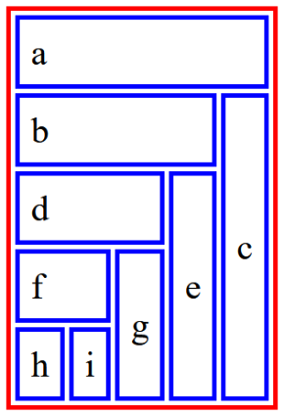

**3:** Using rowspan, colspan, and a table inside of a table create a table that looks like this in your browser (and validates!) Note: for the Description, Qty, Price, and Account Note, I used <th></th> tags.

