Know:
- Terms from the beginning of the year
- HTML tags:
  - Basic template tags
  - All tags covered in class and tutorials, including:
    - Lists
    - Tables
    - images
    - Links:
      - To other web pages on the world wide web
      - To other web pages within your web site
      - To the top of the page
      - To the middle of another web page on your web site
  - Div tags
  - Span tags
  - Adding ids
  - Adding classes
- CSS:
  - All styling options covered in tutorials
  - Background images: tiled, not repeating and positioned, only tiling up and down, only tiling across
  - Padding versus margin
  - Width versus border-width
  - Styling ids
  - Styling classes
  - Styling tags within a div tag
  - Positioning: absolute, fixed, relative, and float

- Colors: RGB and hex

Chocolate Code-off Challenge:
Note that in the code-off, there are references to images and to pixel distances. Since you can’t necessarily precisely draw a vampire or 32 pixels in from the left, I’m looking for the general idea. Guestimates are fine.
Match the following: (1 pt each, 8 pts total)
- Internet  - TCP/IP  - HTTP  - Browser  - URL  - Server  - HTML  - CSS | - Set of rules used for transferring data and getting it to the right destination  - Requests web page from server and displays web page  - Unique address for every web page on the www  - Tells data where to go next across the internet  - Divisions in web pages to make styling easier  - For formatting web pages  - Large, lots of resources, always available, honors requests  - Rules for transferring web pages across the internet  - Used for styling web pages  - Unique address for every computer connected to the internet  - A set of networks connected by a common set of rules
Match the following: (1 pt each, 9 pts total)
- #CA2FD1;  - #DE3125;  - rgb(22, 222, 233);  - #000000;  - rgb(255,255,255);  - #8A8A8A;  - rgb(13, 31,244);  - #2FF22F;  - rgb(244, 236,22); | - Reddish  - Yellowish  - Greenish  - Cyanish (Green-Blueish)  - Purplish  - Bluish  - Black  - White  - Gray

Problem 1: (4 pts, 1 pt each)
There are at least 5 things that won’t validate about this code. List 4 (with the line number) and explain why they are invalid (Note: don’t worry about bad quotes. MS word uses invalid quotation marks – just ignore them)
1  2  3  4  5  6  7  8  9  10  11  12  13  14  15  16  17  18  19  20  21  22  23  24 | <!doctype html>  <html>  <head>  <meta charset = "utf-8">  <title> An Awesome Web Page </title>  <h1> Web Stuff</h1>  </head>  <body>  <div id = "web">  <h2>Random Web Page </h2>  <p>  <a href = "#web">link</a>  Here is where there's <div class = “boldtext”> stuff </div> about the web.  <img src = "Images/web.jpg" width = "100" height = "150">  </p>  <h2>Part Two </h2>  <ul> Top 2 Cereals  <li> Cheerios </li>  <li><h3>Honey Nut Cheerios </h3></li>  <ul>  <a id = "web"> bottom of web page </a>  </div>  </body>  </html>

- __________________________________________________________________________________
- __________________________________________________________________________________
- __________________________________________________________________________________
- __________________________________________________________________________________
Problem 2: (2 pt) Given the following code snippet, add code so that the image becomes a link to the University of Delaware: (udel.edu)

<img src = “bluehen.jpg” height = “100” width = “100” alt = “Delaware’s logo”>

Problem 3: (2 pt) Given the following code snippet, create a link to the text, “Best Web Page”:
<body>
<h1 id = “top”> Requirements </h1>
<h2 id = “t2”>Best Web Page </h2>
<p id = “p1”>This is a web page on rules for making a good web page </p>
<p id = “p2”>Frankenstein (there had to be a monster in here somewhere… </p>
<p id = “p3”> ___________________________________________________________ </p>

Problem 4: (4 pts) Given the following html code snippet, draw the (partial) web page that would result:
<ol>
<li>Zombie
</li>
<li>Witch
<ul><li> Ursula
</li>
<li>Belatrix
</li>
<li>Melisandre
</li>
</ul>
</li>
<li>werewolf
</li>
</ol>

Problem 5: (5 pts) Given the following html code snippet, draw the (partial) web page that would result:
<form>
<p>
<input type = "radio" name = "gore" value = "ghost"> ghoul <br>
<input type = "radio" name = "gore" value = "teeth" checked = "checked"> vampyre <br>
<input type = "radio" name = "gore" value = "brew"> witch <br>
</p>
<p><textarea rows = "3" cols = "100"> How can we scare you?</textarea>
</p>
<p><input type = "button" value = "get scared">
</p>
</form>

Problem 6: (5 pts)Given the following html and css snippets, draw the resulting web page:
<style>
h2 { border-style: solid;
border-width: 2px;
border-color: black;
padding-top: 80px;
padding-bottom: 0px;
text-align: right;
font-style: italic;
font-size: 350%;
background-image: url(Images/smallghost2.png);
background-repeat: no-repeat;
background-position: top right;
}
</style>
</head>
<body>
<h2> Unearthly </h2>
</body>

Problem 7: (6 pts) Given the following HTML and CSS snippets, draw the resulting web page (pay attention to padding and margins):
<style>
#ghost { width: 200px;
border-style: solid;
border-color: black;
border-width: 2px;
padding: 0px;
margin: 25px;
float: right;
}
#all { width: 300px;
border-style: dashed;
border-color: black;
border-width: 2px;
margin: auto;
padding: 0px;
}
#bottom {clear: right;}

</style>
</head>
<body>
<div id = "all">
<p> eek eek eek eek eek eek eek eek eek
</p>
<div id = "ghost">
<img src = "Images/ghost2.jpg" width = "150" height = "200"
alt = "silly ghost">
</div>
<p> boo boo boo boo boo boo boo boo boo
</p>
<div id = "bottom"> </div>
</div>
</body>

Problem 8: (7 pts) The following code snippet in and of itself, results in the web page (shown below the code):
<img src = "Images/bats.gif" id = "b1" width="300" height = "450"
alt = "flying bats">
<img src = "Images/fangs.gif" id = "f1" width="90" height = "60"
alt = "fangs with blood">
<img src = "Images/ghost.png" id = "c1" height = "300" width = "250"
alt = "cow pic">
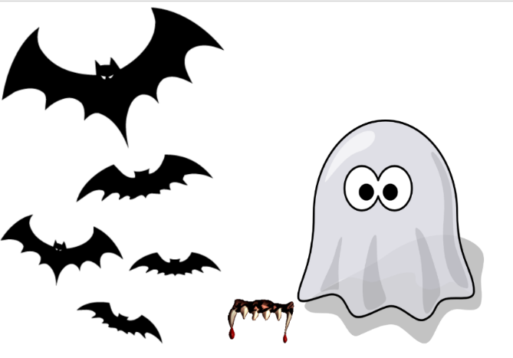
The above code snippet would result if no css was included, if, however, the css below was included, draw the resulting web page (rough estimates are fine):
#b1 { width: 300px;
z-index:2;
}
#f1 {position: relative;
top: -40px;
left: -210px;
z-index: 8;
}

#c1 {position: relative;
top: 30px;
left: -390px;
z-index: 5;
}

Problem 9: (10 pts) Given the following html/css code, draw the web page that would result:
<!doctype html>
<html>
<head>
<meta charset = "utf-8">
<title> An Awesome Web Page </title>
<style> p { width: 20px;
padding-top: 10px;
padding-bottom: 10px;
border-style: solid;
border-width: 3px;
border-color:black;
text-align: center;
background-color: white;
}
#p1 { position: absolute; top: 10px; left: 60px; z-index: 3}
#p2 { position: absolute; top: 10px; left: 60px; z-index: 5}
#p3 { position: absolute; top: 15px; left: 10px; z-index: -1}
#p4 { position: absolute; top: 10px; left: 110px; z-index: 3}
#p5 { position: absolute; top: 15px; left: 10px; z-index: 1}
#p6 { position: absolute; top: 20px; left: 85px; z-index: 3}
#p7 { position: absolute; top: 20px; left: 35px;}
#p8 { position: absolute; top: 20px; left: 85px; z-index: 5}
</style>
</head>
<body>
<p id = "p1">A</p>
<p id = "p2">Y</p>
<p id = "p3">E</p>
<p id = "p4">T</p>
<p id = "p5">C</p>
<p id = "p6">F</p>
<p id = "p7">R</p>
<p id = "p8">P</p>
</body>
</html>
 | 0 | 10 |  | 20 |  | 30 | 40 | 50 | 60 | 70 | 80 | 90 | 100 | 110 | 120 | 130
0
10
20
30
40
50
60
70
80
90
100
110
Problem 10: (10 pts) Given the following html and css code, draw what is created:
<head>
<meta charset = "utf-8">
<title> An Awesome Web Page </title>
<style>
table {border-style: solid; border-color: black; border-width: 2px;}
td {border-style: solid; border-color: black; border-width: 2px;text-align: center;}

</style>
</head>
<body>
<table>
<tr><td rowspan = "3">boo</td>
<td rowspan = "2">eek</td>
<td>ack</td>
<td rowspan = "2">arg</td>
<td rowspan = "3">wow</td>
</tr>
<tr><td>yikes</td>
</tr>
<tr><td colspan = "3">squeek</td>
</tr>
<tr><td colspan = "5">chillbumps</td>
</tr>
</table>

</body>

