Final Project: Pig

For those of you who’ve never played Pig, the object of the game is to get at or over 100 points before the other player does. You get points by taking turns. In each turn, you repeatedly roll a die (the singular version of dice) until either a 2 is rolled or the player passes and scores the sum of the rolls from that turn(i.e. the turn total). At any time during a player's turn, the player is faced with two options:

* **roll** - If the player rolls a
  + **2**: the player scores nothing for the turn and it becomes the next player's turn.
  + **any other number:** the number is added to the player's turn total and the player's turn continues.
* **pass** - The turn total is added to the player's total score and it becomes the next player's turn.

The first player to score 100 or more points wins.

In our version, there will be 2 players, you and the computer. For this project, you can choose the level of difficulty you wish to accomplish.

# First Level (worth 75 points):

For this level, you will create a **web page** that looks something like this (Note: you have some freedom with this – be creative if you wish to make it look more professional).

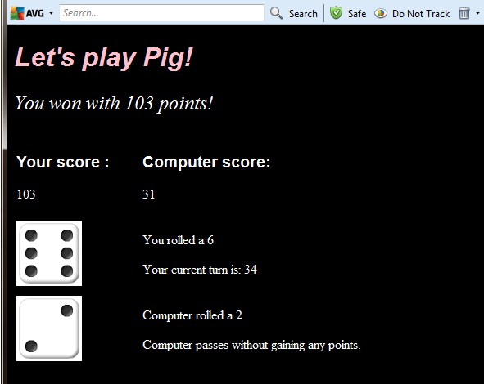

In your web page there must be:

* a paragraph for your total score
* a paragraph for the computer’s total score
* a paragraph for displaying your current die roll
* a paragraph for your current number of points for your turn
* a paragraph for displaying the computer’s current die roll
* a paragraph for the computer’s current number of points for the computer’s turn
* a paragraph where you will display who won
* an image for your dice rolls (showing the die you roll as you roll them throughout your turn)
* an image for the computer’s dice roll (showing the die the computer rolls as it rolls throughout its turn
* A paragraph that contains the word “Click to start”. This paragraph will call the yourturn() javascript function when you click on above text.

*(Remember: some of these are text and some are images. Make sure you use the appropriate commands for the appropriate element).*

You will also need to write the **javascript** for the two turns.

At the top of your javascript you will need:

* an array of images of die faces (or pig positions), 1 through 6.
* 2 variables, one for your total score, and one for the computer’s total score, both set to 0.
* 2 more variables, computercount (for the count of the number of times you’ve called setTimeout(), so the count of the loops the computer has done) and computerturn (a variable for the computer’s current turn score). Set both to 0

And you will need three functions: yourturn() for your turn at the game, computerinit() to initialize the computer’s turn (as in the tutorial and as we did in class), and computerturn() for the computer’s turn at the game.

***Inside the function yourturn():***

1. Initialize a currentturn variable to 0
2. initialize a count variable to 0,
3. create a while loop that will loop 5 times. Each time inside the loop you will:
   1. generate a random number between 0 and the length of the array
   2. display that image from the array in the image space on your web page set aside for your die roll
   3. print that number in the paragraph set aside for printing your current die roll
   4. add that number to the current turn’s score
   5. print the current turn’s score in the paragraph devoted to printing your current turn’s score.
   6. increase the count variable by 1 (so that you don’t loop forever)

After the loop has looped 5 times,

1. add the current turn’s score to your total score,
2. print your total score in the paragraph on the page for your total score,
3. call the computerinit() function.

(Note: the computer processes over 2 billion instructions per second. Yep, I said 2 billion. That means that most likely this function will loop so fast you won’t be able to see it happen. You will only see the final die roll, the final turn score, and the adjustment in your total score on the web page.)

***The computerinit() function will be quite short. In it you will***:

1. set computerturn to 0
2. set computerct to 0
3. call the function computerturn(). (This is just like the tutorial and like we did in class).

***For the computerturn() function, you will be using the setTimeout() function to loop 5 times.***

1. check if computercount is less than 5 and, if so:
   1. generate a random number between 0 and the length of the array
   2. display that image from the array in the image space on your web page set aside for the computer’s die roll
   3. print that number in the paragraph set aside for printing the computer’s current die roll
   4. add that number to the current turn’s score
   5. print the current turn’s score in the paragraph devoted to printing your current turn’s score.
   6. Add 1 to the computercount (so that eventually you stop calling setTimeout())

After 5 rolls (when computerct == 5), you will:

1. add the computerturn points to the to the computer’s total score
2. print that in the paragraph on the page for the computer’s total.
3. check whether you have more total points or the computer has more total points
4. print out the winner (and his/her winning score) in the paragraph on your web page set aside for printing who won.

***End of First Level***

***_____________________________________________________________________________________***

# Level 2 (in combination with Level 1, worth 85 pts):

Modify both the yourturn() function and the computerturn() function so that if either you or the computer rolls a 0, you stop looping and get a 0 for your turn.

Note that there is definitely more than one way to do this. For your turn, for instance, you may want to check if you randomly generated a 2 inside the loop, and, if so, set the yourturn variable to 0 and the count to 5, so you’ll stop looping and fall out. For the computer’s turn, you again would want to set the computerturn variable to 0 and then set the computercount to 5 as well, so you’ll stop calling setTimeout().

Now the rolling of a 2 for either of you should result in a turn score of 0 for that player, a total score of 0 for that player, and that will be reflected in who won.

***End of Second Level***

***_____________________________________________________________________________________***

# Level 3 (in combination with Level 1 and 2, worth 90 pts):

Modify just the yourturn() function so that now, instead of looping for 5 times, it will ask the user, “Do you want to continue?” using the confirm box. So now, while the user clicks “ok”, the loop will continue. When the user clicks, “cancel”, the loop will stop and the turn will be transferred to the computer (as before).

***End of Third Level***

***_____________________________________________________________________________________***

# Level 4 (in combination with Level 1, 2 and 3, worth100 pts):

Modify your code so that, instead of just having you go once and the computer go once, you’ll continue to go back and forth until one of you reaches 100 or more. To do this, you’ll need to change computerturn so that you’re modifying steps 4 and 5 under computerturn. First, it will need to check to see whether the computer’s total score is >= to 100. If so, you’ll need to do step 5. If not, then it will call yourturn().

You will also need to modify yourturn() slightly. It will also need to check if, after you’ve added the turn’s points to the user’s total points (steps 4 and 5 under userturn) the user’s total points are >= 100. If so, you’ll have to print out the winner (and his/her winning score) in the paragraph on your web page set aside for printing who won. If not, you’ll call the computerinit function (as you did in step 6 under userturn).

***End of Fourth Level***

***_____________________________________________________________________________________***

# Extra Level (in combination with Level 1, 2 3, and 4, worth110 pts):

Modify your game so that if you roll 2 1s in a row, you’ll lose all of your total score points, but if you roll a 1 followed by a 6, you double your turn’s points. Do the same for the computer.