Exercise 1: uses document.getElementsById to modify the text in a paragraph and a while loop:
Create a web page with a paragraph that holds the character ‘y’ and that’s it.
Create a button on the web page that calls a function. It should call the function with a number as an input parameter
Now in the head section, write a javaScript function that has one input parameter. The function first gets the innerHTML of the paragraph above, and then uses a while loop to loop the input number of times, adding an ‘l’ to the variable holding the innerHTML.
When the loop is done, it adds ‘rea’ to the beginning of the innerHTML and then changes the paragraph’s innerHTML to the new variable created.
For instance, if myfunc(9), then the paragraph will end up being”reallllllllly”.
Exercise 2: Create a web page with a paragraph on it. The paragraph should start by saying, “but why?”. It also should call a function. In the javaScript, the function should have a prompt asking, ‘but why’. It should have a while loop, and while the answer to the prompt isn’t ‘because I said so’, the user will be prompted again with, ‘but why’? When the user answers ‘because I said so, then the paragraph will be changed to, ‘oh, okay’.
Exercise 3: Create a web page with a paragraph on it. The paragraph should start by saying “adding exercise”. It also should call a function with a number as an input parameter. In the javaScript, the function should have 1 parameter and it should then have 2 variables. One starts by being set to 0. The other starts by being set to an empty string (“” is an empty string).
There should then be a while loop that loops the input parameter number of times. Each time it loops, it should generate a random number between 0 and 10. It should add that number to the variable that started at 0, and it should also join that number and a “+” to the variable that started as an empty string (e.g., stringvar = stringvar + randnum + “+”)
Outside of the while loop the function should generate one last random number and add it to the number var and the string var (without a “+”) this time). The string var should then add on a “=” and the number var. Then the innerHTML of the paragraph should be changed to the string.
So,for instance, if the input parameter is 5, the resulting paragraph could be:
3+7+2+1+4+4 = 21
Exercise 4a: Create a web page with a bunch of paragraphs on it as well as a few headers. Now create a javaScript with a function that has an input parameter. Lets assume the input parameter is ‘P’ for now. Use getElementsByTagName ((don’t forget the s – I do…) to put all the paragraphs in an array. Now use a while loop to change the color of each paragraph’s background color, font color, border color, and drop shadow color to the different colors. You may pick a color theme if you want.
In your web page add a button that calls the function. Call the function with ‘P’. Then change it to call the function with ‘H1’. Then try calling the function with ‘*’. That should change the style of everything on the web page.
Exercise 4b: Copy the web page above to a new web page. Add to the above script an array of colors. Now in the function generate 4 random numbers between 0 and the length of the color array. Use while loops to make sure that all four numbers are different. Now use a different while loop to change the color of each paragraph’s background color, font color, border color, and drop shadow color to the different colors. (Note that this is an awful lot like the exercise we did in class)
Now add a start function that prompts(“Change headers, paragraphs, or all?”) Inside the start function, if the user types ‘headers’, the function should be called with ‘H1’. If the user types paragraphs, the function should be called with ‘P’. And if the user types ‘all’, the function should be called with ‘*’.
Exercise 5: Make a web page with a bunch of head images (or whatever makes less sense to you). Use document.getElementsByTagName with ‘img’ to make an array of all the images on the web page. Now use a while loop to rotate all the heads. Each of the heads should rotate a different amount. So generate a different random number between 0 and 180. And then rotate the image of the head in the array by that random number using style.transform = "rotate("+x+"deg)" where x is the random number. Note – I wanted some heads to rotate right, and some left, so in the random number generator I subtracted 90, thus getting some negative numbers, which rotated the head to the left.
I got:
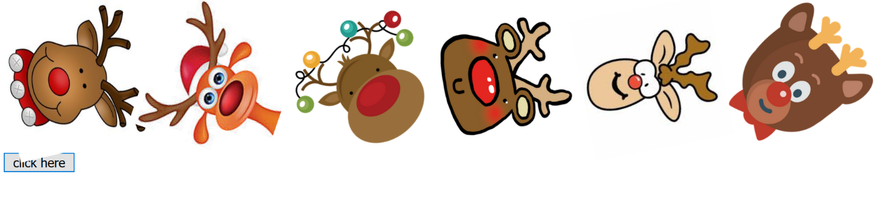

Exercise 6: part 1: write a web page with all the letters of the alphabet in a separate paragraph. Each paragraph should call a function with the letter in the paragraph. I’m giving you this part below to save time. Now in your web page make a h1 for a word, with an id. Make an h2 below it for the text you “type” in, and an h3 for the score.
Now the javaScript part:
Create an array of random words you happen to like. I went with a winter theme. Go with what pleases you. You should also have a score variable, set to 0.
Now create a function that generates a random number between 0 and the length of the word array. Change the innerHTML of the word h1 to the appropriate random word from the array. Change the innerHTML of the h2 text to a blank string (“”). And use setTimeout to call this function at some longer time you pick (I was at 9000 when I gave up, but it might actually have to be longer than that to successfully play this game).
Next function: a function that randomly moves each of the letter paragraphs (from below) around the screen. You will need to use getElementsByTagName and a while loop for this.
Inside the while loop, generate a random number between 0 and 1. If it’s 0, set that particular paragraph’s visibility to “hidden” (.style.visibility = "hidden") if it’s 1, set the visibility to “visible”.
Generate 2 more random numbers (maybe between 100 and 600). Change that particular paragraph’s top and left position to those random numbers.
Outside the while loop use setTimeout to call this function every maybe 3000 milliseconds (again, you may need longer to actually play this game) so that the letters move around every 3 seconds.
2 more functions: the function func, which takes as an input parameter the letter in the paragraph. This is the function that is called when you click on any of the paragraphs (below). In this function, first get the innerHTML of the text h2 and place it in a variable. Then add the letter (the input parameter) to the end of the variable. And then change the innerHTML of the text h2 back to the newly updated variable (so that it adds each letter to the innerHTML as you click on the letters).
Get the innerHTML of the word h1, and check to see if it is equal to the text h2 innerHTML (we’re checking to see if what you’ve clicked on made the same word as the word currently showing on the page). If it is, increase the score by 10 and change the innerHTML of the score h3 so it holds the new score.
And one last function. A start function that calls the function that selects the random word, and the function that starts the letters moving around randomly.
I’ve included a screenshot of the game in progress, below (and below that is the paragraphs with all the letters).
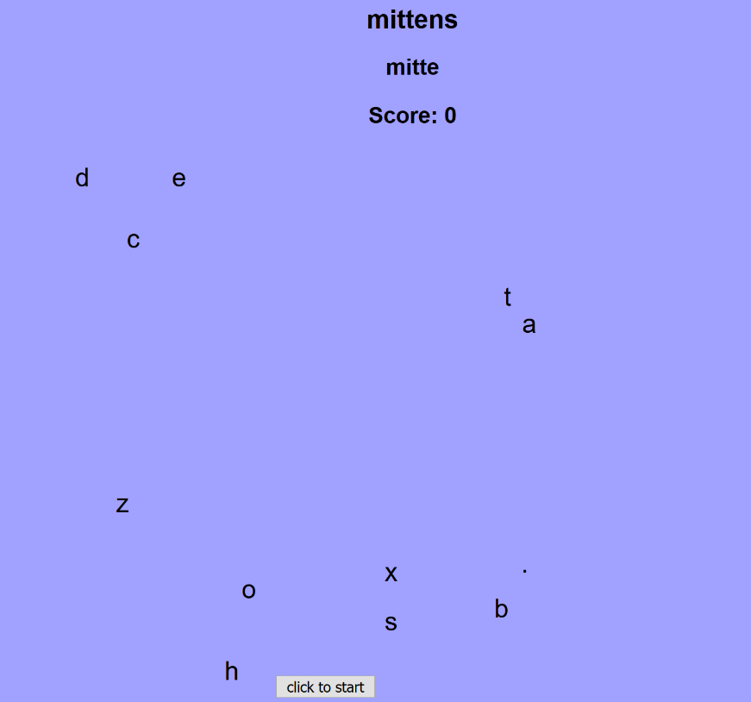
<p onClick = func('a')>a</p>
<p onClick = func('b')>b</p>
<p onClick = func('c')>c</p>
<p onClick = func('d')>d</p>
<p onClick = func('e')>e</p>
<p onClick = func('f')>f</p>
<p onClick = func('g')>g</p>
<p onClick = func('h')>h</p>
<p onClick = func('i')>i</p>
<p onClick = func('j')>j</p>
<p onClick = func('k')>k</p>
<p onClick = func('l')>l</p>
<p onClick = func('m')>m</p>
<p onClick = func('n')>n</p>
<p onClick = func('o')>o</p>
<p onClick = func('p')>p</p>
<p onClick = func('q')>q</p>
<p onClick = func('r')>r</p>
<p onClick = func('s')>s</p>
<p onClick = func('t')>t</p>
<p onClick = func('u')>u</p>
<p onClick = func('v')>v</p>
<p onClick = func('w')>w</p>
<p onClick = func('x')>x</p>
<p onClick = func('y')>y</p>
<p onClick = func('z')>z</p>
<p onClick = func('.')>.</p>

