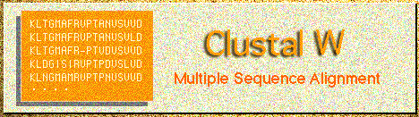

CLUSTALW: Multiple Sequence Alignment[help]

Top of Form
General Setting Parameters:
Output Format:
Pairwise Alignment: FAST/APPROXIMATE SLOW/ACCURATE
Enter your sequences (with labels) below (copy & paste): PROTEIN DNA
Support Formats: FASTA (Pearson), NBRF/PIR, EMBL/Swiss Prot, GDE, CLUSTAL, and GCG/MSF
Or give the file name containing your query

More Detail Parameters...
Pairwise Alignment Parameters:
For FAST/APPROXIMATE:
K-tuple(word) size: , Window size: , Gap Penalty:
Number of Top Diagonals: , Scoring Method:
For SLOW/ACCURATE:
Gap Open Penalty: , Gap Extension Penalty:
Select Weight Matrix:
(Note that only parameters for the algorithm specified by the above "Pairwise Alignment" are valid.)
Multiple Alignment Parameters:
Gap Open Penalty: , Gap Extension Penalty:
Weight Transition: YES (Value: ), NO
Hydrophilic Residues for Proteins:
Hydrophilic Gaps: YES NO
Select Weight Matrix:
Type additional options (delimited by whitespaces) below:
(-options for help)
Bottom of Form
Last update Dec. 3, 2000

SIT sequence interpretation tools, GenomeNet

CLUSTALW Result
GenomeNet CLUSTALW Server (Kyoto Center) on Sat Mar 16 08:30:27 JST 2002

CLUSTAL W (1.81) Multiple Sequence Alignments

Sequence type explicitly set to DNA
Sequence format is Pearson
Sequence 1: bacillus-cereus 537 bp
Sequence 2: bacillus-badius 538 bp
Sequence 3: bacillus-circulans 532 bp
Sequence 4: bacillus-pumilus 534 bp
Sequence 5: pseudomonas-aeruginosa 522 bp
Sequence 6: pseudomonas-flavescens 522 bp
Sequence 7: pseudomonas-fluorescens 522 bp
Sequence 8: pseudomonas-putida 522 bp
Start of Pairwise alignments
Aligning...
Sequences (6:7) Aligned. Score: 94
Sequences (7:8) Aligned. Score: 96
Sequences (5:6) Aligned. Score: 94
Sequences (2:3) Aligned. Score: 94
Sequences (1:2) Aligned. Score: 91
Sequences (3:4) Aligned. Score: 93
Sequences (6:8) Aligned. Score: 96
Sequences (5:7) Aligned. Score: 93
Sequences (2:4) Aligned. Score: 93
Sequences (1:3) Aligned. Score: 91
Sequences (3:5) Aligned. Score: 76
Sequences (5:8) Aligned. Score: 93
Sequences (2:5) Aligned. Score: 78
Sequences (1:4) Aligned. Score: 92
Sequences (3:6) Aligned. Score: 75
Sequences (4:5) Aligned. Score: 78
Sequences (2:6) Aligned. Score: 76
Sequences (1:5) Aligned. Score: 76
Sequences (3:7) Aligned. Score: 75
Sequences (4:6) Aligned. Score: 77
Sequences (2:7) Aligned. Score: 77
Sequences (3:8) Aligned. Score: 75
Sequences (1:6) Aligned. Score: 75
Sequences (4:7) Aligned. Score: 75
Sequences (2:8) Aligned. Score: 76
Sequences (1:7) Aligned. Score: 76
Sequences (4:8) Aligned. Score: 75
Sequences (1:8) Aligned. Score: 75
Guide tree file created: [clustalw.dnd]
Start of Multiple Alignment
There are 7 groups
Aligning...
Group 1: Sequences: 2 Score:9617
Group 2: Sequences: 3 Score:9515
Group 3: Sequences: 4 Score:9394
Group 4: Sequences: 2 Score:9661
Group 5: Sequences: 3 Score:9571
Group 6: Sequences: 4 Score:9503
Group 7: Sequences: 8 Score:7730
Alignment Score 82801
CLUSTAL-Alignment file created [clustalw.aln]
CLUSTAL W (1.81) multiple sequence alignment

bacillus-badius TGGAGAGTTTGATCCTGGCTCAGGACGAACGCTGGCGGCGTGCCTAATAC
bacillus-circulans TGGAGAGTTTGATCCTGGCTCAGGACGAACGCTGGCGGCGTGCCTAATAC
bacillus-pumilus TGGAGAGTTTGATCCTGGCTCAGGACGAACGCTGGCGGCGTGCCTAATAC
bacillus-cereus TGGAGAGTTTGATCCTGGCTCAGGATGAACGCTGGCGGCGTGCCTAATAC
pseudomonas-fluorescens TGGAGAGTTTGATCCTGGCTCAGATTGAACGCTGGCGGCAGGCCTAACAC
pseudomonas-putida TGGAGAGTTTGATCCTGGCTCAGATTGAACGCTGGCGGCAGGCCTAACAC
pseudomonas-flavescens TGGAGAGTTTGATCCTGGCTCAGATTGAACGCTGGCGGCAGGCCTAACAC
pseudomonas-aeruginosa TGGAGAGTTTGATCCTGGCTCAGATTGAACGCTGGCGGCAGGCCTAACAC
*********************** ************* ****** **

bacillus-badius ATGCAAGTCGAGCGGACTTGACGGAAGCTTGCTTCCGTTCAAGTTAGCGG
bacillus-circulans ATGCAAGTCGAGCGGACTTTA--AAAGCTTGCTT---TTAAAGTTAGCGG
bacillus-pumilus ATGCAAGTCGAGCGGACAGAA-GGGAGCTTGCTCC--CGGATGTTAGCGG
bacillus-cereus ATGCAAGTCGAGCGAATGGATTAAGAGCTTGCTCTT-ATGAAGTTAGCGG
pseudomonas-fluorescens ATGCAAGTCGAGCGGTAGAGA--GAAGCTTGCTT---CTCTTGAGAGCGG
pseudomonas-putida ATGCAAGTCGAGCGGATGAGA--AGAGCTTGCTC---TTCGATTCAGCGG
pseudomonas-flavescens ATGCAAGTCGAGCGGTTGAGG--GGAGCTTGCTC---CCTGATTCAGCGG
pseudomonas-aeruginosa ATGCAAGTCGAGCGGATGAAG--GGAGCTTGCTC---CTGGATTCAGCGG
************** ******** *****

bacillus-badius CGGACGGGTGAGTAACACGTGGGTAACCTGCCTGTAAGACTGGGATAACT
bacillus-circulans CGGACGGGTGAGTAACACGTGGGCAACCTGCCTGTAAGACTGGGATAACT
bacillus-pumilus CGGACGGGTGAGTAACACGTGGGTAACCTGCCTGTAAGACTGGGATAACT
bacillus-cereus CGGACGGGTGAGTAACACGTGGGTAACCTGCCCATAAGACTGGGATAACT
pseudomonas-fluorescens CGGACGGGTGAGTAAAGCCTAGG-AATCTGCCTGGTAGTGGGGGATAACG
pseudomonas-putida CGGACGGGTGAGTAATGCCTAGG-AATCTGCCTGGTAGTGGGGGACAACG
pseudomonas-flavescens CGGACGGGTGAGTAATGCCTAGG-AATCTGCCTATTAGTGGGGGACAACG
pseudomonas-aeruginosa CGGACGGGTGAGTAATGCCTAGG-AATCTGCCTGGTAGTGGGGGATAACG
*************** * * ** ** ***** ** **** ***

bacillus-badius CCGGGAAACCGGGGCTAATACCGGATATTCTTTTTCTTCGCATGAAGAAG
bacillus-circulans TCGGGAAACCGGAGCTAATACCGGATAATCCTTTTCCTCTCATGAGGAAA
bacillus-pumilus CCGGGAAACCGGAGCTAATACCGGATAGTTCCTTGAACCGCATGGTTCAA
bacillus-cereus CCGGGAAACCGGGGCTAATACCGGATAACATTTTGAACCGCATGGTTCGA
pseudomonas-fluorescens TTCGGAAACGGACGCTAATACCGCATA--------CGTCCTACGGGAGAA
pseudomonas-putida TTTCGAAAGGAACGCTAATACCGCATA--------CGTCCTACGGGAGAA
pseudomonas-flavescens TTTCGAAAGGAACGCTAATACCGCATA--------CGTCCTACGGGAGAA
pseudomonas-aeruginosa TCCGGAAACGGGCGCTAATACCGCATA--------CGTCCTGAGGGAGAA
**** ********** *** * *

bacillus-badius AATGGAAAGGCGGCTTTTAGCTGTCACTTACAGATGGACCCGCGGCGCAT
bacillus-circulans AGCTGAAAGACGGTTTAC-GCTGTCACTTACAGATGGGCCCGCGGCGCAT
bacillus-pumilus GGATGAAAGACGGTTT-CGGCTGTCACTTACAGATGGACCCGCGGCGCAT
bacillus-cereus AATTGAAAGGCGGCTT-CGGCTGTCACTTATGGATGGACCCGCGTCGCAT
pseudomonas-fluorescens AGCAGGGGACC--TTCGGGCCTTGCGCTATCAGATGAGCCTAGGTCGGAT
pseudomonas-putida AGCAGGGGACC--TTCGGGCCTTGCGCTATCAGATGAGCCTAGGTCGGAT
pseudomonas-flavescens AGCAGGGGACC--TTCGGGCCTTGCGCTAATAGATGAGCCTAGGTCGGAT
pseudomonas-aeruginosa AGTGGGGGATC--TTCGGACCTCACGCTATCAGATGAGCCTAGGTCGGAT
* * * ** * ** **** ** * ** **

bacillus-badius TAGCTAGTTGGTGAGGTAACGGCTCACCAAGGCAACGATGCGTAGCCGAC
bacillus-circulans TAGCTAGTTGGTGAGGTAACGGCTCACCAAGGCGACGATGCGTAGCCGAC
bacillus-pumilus TAGCTAGTTGGTGGGGTAATGGCTCACCAAGGCGACGATGCGTAGCCGAC
bacillus-cereus TAGCTAGTTGGTGAGGTAACGGCTCACCAAGGCAACGATGCGTAGCCGAC
pseudomonas-fluorescens TAGCTAGTTGGTGAGGTAATGGCTCACCAAGGCGACGATCCGTAACTGGT
pseudomonas-putida TAGCTAGTTGGTGAGGTAATGGCTCACCAAGGCGACGATCCGTAACTGGT
pseudomonas-flavescens TAGCTAGTTGGTGGGGTAAAGGCTCACCAAGGCGACGATCCGTAACTGGT
pseudomonas-aeruginosa TAGCTAGTTGGTGGGGTAAAGGCCTACCAAGGCGACGATCCGTAACTGGT
************* ***** *** ******** ***** **** * *

bacillus-badius CTGAGAGGGTGATCGGCCACACTGGGACTGAGACACGGCCCAGACTCCTA
bacillus-circulans CTGAGAGGGTGATCGGCCACACTGGGACTGAGACACGGCCCAGACTCCTA
bacillus-pumilus CTGAGAGGGTGATCGGCCACACTGGGACTGAGACACGGCCCAGACTCCTA
bacillus-cereus CTGAGAGGGTGATCGGCCACACTGGGACTGAGACACGGCCCAGACTCCTA
pseudomonas-fluorescens CTGAGAGGATGATCAGTCACACTGGAACTGAGACACGGTCCAGACTCCTA
pseudomonas-putida CTGAGAGGATGATCAGTCACACTGGAACTGAGACACGGTCCAGACTCCTA
pseudomonas-flavescens CTGAGAGGATGATCAGTCACACTGGAACTGAGACACGGTCCAGACTCCTA
pseudomonas-aeruginosa CTGAGAGGATGATCAGTCACACTGGAACTGAGACACGGTCCAGACTCCTA
******** ***** * ******** ************ ***********

bacillus-badius CGGGAGGCAGCAGTAGGGAATCTTCCGCAATGGACGAAAGTCTGACGGAG
bacillus-circulans CGGGAGGCAGCAGTAGGGAATCTTCCGCAATGGACGAAAGTCTGACGGAG
bacillus-pumilus CGGGAGGCAGCAGTAGGGAATCTTCCGCAATGGACGAAAGTCTGACGGAG
bacillus-cereus CGGGAGGCAGCAGTAGGGAATCTTCCGCAATGGACGAAAGTCTGACGGAG
pseudomonas-fluorescens CGGGAGGCAGCAGTGGGGAATATTGGACAATGGGCGAAAGCCTGATCCAG
pseudomonas-putida CGGGAGGCAGCAGTGGGGAATATTGGACAATGGGCGAAAGCCTGATCCAG
pseudomonas-flavescens CGGGAGGCAGCAGTGGGGAATATTGGACAATGGGCGAAAGCCTGATCCAG
pseudomonas-aeruginosa CGGGAGGCAGCAGTGGGGAATATTGGACAATGGGCGAAAGCCTGATCCAG
************** ****** ** ****** ****** **** **

bacillus-badius CAACGCCGCGTGAGTGAAGAAGGTTTTCGGATCGTAAAGCTCTGTTGTCA
bacillus-circulans CAACGCCGCGTGAGTGATGAAGGTTTTCGGATCGTAAAACTCTGTTGTTA
bacillus-pumilus CAACGCCGCGTGAGTGATGAAGGTTTTCGGATCGTAAAGCTCTGTTGTTA
bacillus-cereus CAACGCCGCGTGAGTGATGAAGGCTTTCGGGTCGTAAAACTCTGTTGTTA
pseudomonas-fluorescens CCATGCCGCGTGTGTGAAGAAGGTCTTCGGATTGTAAAGCACTTTAAGTT
pseudomonas-putida CCATGCCGCGTGTGTGAAGAAGGTCTTCGGATTGTAAAGCACTTTAAGTT
pseudomonas-flavescens CCATGCCGCGTGTGTGAAGAAGGTCTTCGGATTGTAAAGCACTTTAAGTT
pseudomonas-aeruginosa CCATGCCGCGTGTGTGAAGAAGGTCTTCGGATTGTAAAGCACTTTAAGTT
* * ******** **** ***** ***** * ***** * ** *

bacillus-badius GGGAAGAACAAGTACGGAAGTAACT-GTCCGTACCTTGACGGTACCTGAC
bacillus-circulans GGGAAGAACAAGTACAAGAGTAACT-GCTTGTACCTTGACGGTACCTAAC
bacillus-pumilus GGGAAGAACAAGTGCGAGAGTAACT-GCTCGCACCTTGACGGTACCTAAC
bacillus-cereus GGGAAGAACAAGTGCTAGTTGAATAAGCTGGCACCTTGACGGTACCTAAC
pseudomonas-fluorescens GGGAGGAA-GGGCATTAACCTAATACGTTAGTGTTTTGACGTTACCGACA
pseudomonas-putida GGGAGGAA-GGGCATTAACCTAATACGTTAGTGTTTTGACGTTACCGACA
pseudomonas-flavescens GGGAGGAA-GGGCAGTAAGCGAATACCTTGCTGTTTTGACGTTACCGACA
pseudomonas-aeruginosa GGGAGGAA-GGGCAGTAAGTTAATACCTTGCTGTTTTGACGTTACCAACA
**** *** * ** ****** ****

bacillus-badius CAGAAAGCCACGGCTAACTACGTGCCAGCAGCCGCGGTA
bacillus-circulans CAGAAAGCCACGGCTAACTACGTGCCAGCAGCCGCGGTA
bacillus-pumilus CAGAAAGCCACGGCTAACTACGTGCCAGCAGCCGCGGTA
bacillus-cereus CAGAAAGCCACGGCTAACTACGTGCCAGCAGCCGCGGTA
pseudomonas-fluorescens GAATAAGCACCGGCTAACTCTGTGCCAGCAGCCGCGGTA
pseudomonas-putida GAATAAGCACCGGCTAACTCTGTGCCAGCAGCCGCGGTA
pseudomonas-flavescens GAATAAGCACCGGCTAACTCTGTGCCAGCAGCCGCGGTA
pseudomonas-aeruginosa GAATAAGCACCGGCTAACTTCGTGCCAGCAGCCGCGGTA
* **** ********* ******************
(
bacillus-cereus:0.04444,
(
(
bacillus-badius:0.02478,
bacillus-circulans:0.03162)
:0.00954,
bacillus-pumilus:0.02887)
:0.00461,
(
pseudomonas-aeruginosa:0.02419,
(
pseudomonas-flavescens:0.02088,
(
pseudomonas-fluorescens:0.01724,
pseudomonas-putida:0.01533)
:0.00785)
:0.01509)
:0.16102);

[N-J Tree] [Unrooted N-J Tree] [Dendrogram] [Unrooted dendrogram]
N-J Tree
[PostScript file]
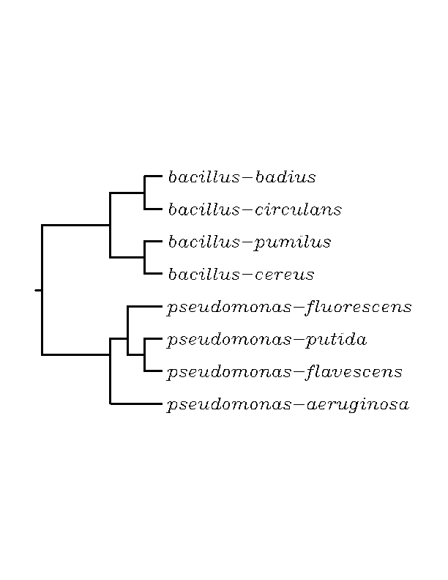
Unrooted NJ Tree

[PostScript file]
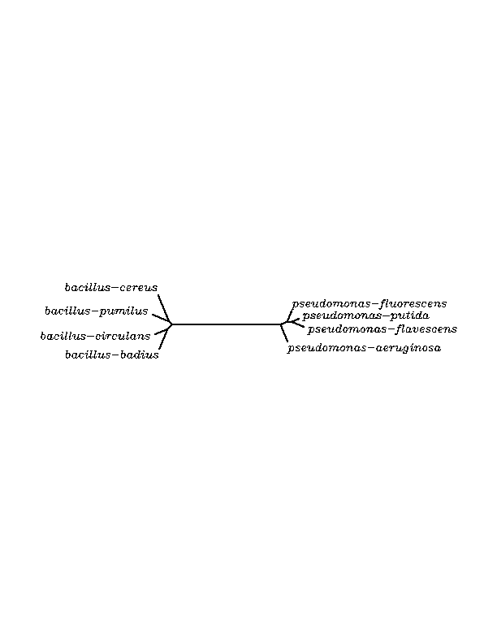
Dendrogram

[PostScript file]
Unrooted Dendrogram
[PostScript file]
