A1. Computer Graphics (25 points)
Texture Mapping.
- [5pts] Build the Summed Area Table for the following texture.

1 | 3 | 5 | 2
6 | 2 | 4 | 1
7 | 5 | 2 | 3
6 | 2 | 3 | 1

- [5pts] Build the MIPMAP hierarchy for the same texture. (Feel free to round the floating point values to integer values at each level if needed).

- [3pts] If the original 2D texture is of size M (bytes), what is the size of its corresponding MIPMAP?

- [12pts] Environment Mapping.
a) [5pts] Given an environment map (spherical map) surrounding a scene, assume the incident ray has normalized direction i, the vertex normal is n, what is the reflected ray direction r?

b) [7pts] Derive the texture coordinate of the reflected ray in the environment map in terms of r (assume r = [r_{x}, r_{y}, r_{z}])?

A2. Computer Graphics (25 points)
Transformation.
1. [10pts] Recall that a viewing transformation from one homogenous coordinate system to another can be written as the product of a rotation matrix R and a translation matrix T. Given a camera viewpoint at [0, 0, 0], a viewing direction of [1, 1, 1], and a “view-up” or sky vector of [0, 1, 0], write down the equation for computing the image right vector r, the image up vector u, and the rotation matrix R. (If you use dot or cross product, you need to write out the explicit result rather than just a x b).
2. Normal Transformation Matrix. If we transform the vertices of a 3D model by a transformation matrix M, derive the corresponding transformation matrix N (in terms of M) for the surface normal by answering the following two parts.
a) [5pts] Given two 3D points x₁ and x₂ on a plane that has normal n, what constraint (equation) should n, x₁ and x₂ satisfy?
b) [10pts] Now that we transform the points x₁ and x₂ with matrix M, we need to transform the normal n accordingly so that the points and the normal still satisfy the constraint above after transformation. Please derive this normal transformation matrix N in terms of M. Show all your work.

A3. Computer Graphics (25 points)
Visibility.
- [8 pts] Explain the Cohen-Sutherland line clipping algorithm, including the role of outcodes. Where does it typically occur in the pipeline? How do the 2-D and 3-D cases differ?

- [8 pts] What are the Z-buffer algorithm and the painter's algorithm for visibility testing? Briefly explain how they work and give at least one positive and one negative feature of each.

- [5 pts] Consider the set of 2-D line segments in the figure below. Suppose we pick the partitioning line for a given level of a binary space partitioning (BSP) tree as the first in a list ordered using the lines' numerical labels. The ordering rule is “smallest-to-largest even numbers, then largest-to-smallest odd numbers."
Give the steps to construct a BSP tree from the figure's line segments using this rule, indicating any splits that are necessary. For clarity, the only splits possible are: line 2 splits 3 and 4, line 1 splits 3, and line 3 splits 5.

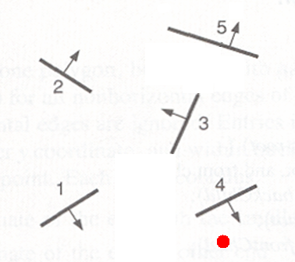

4. [4 pts] Now suppose the viewer is positioned at the dot in the figure. In what order would the BSP tree you constructed be traversed for the painter's algorithm?

A4. Computer Graphics (25 points)
Shading.
- [4 pts] Assume that a certain full-color (24 bit per pixel) RGB raster system has a 2048 by 2048 frame buffer. If 360 megabytes/second is the allowable transfer rate, what is the maximum possible frame rate (frames per second)?
- [3 pts] If objects that a programmer creates would not appear in the final scene, do they still participate in shading? Explain your answer with proper justification.
- a) [10 pts] Give and explain each term of both the diffuse and specular terms of the illumination equation for a single light source. ii) What does the ambient term in the illumination equation model? iii) What effect does ‘shinyness’ term have in the specular term.
      - [4 pts] Modify the above illumination equation to include multiple light sources and light source distance attenuation.
      - [4 pts] Explain how shading of transparent objects is handled.

