Compilers Preliminary Examination 2011

1A. (8 points) Parameter Passing Mechanisms and Scope
Consider the following C program. Simulate the program’s execution. Show both the values that each variable gets assigned upon each assignment, and the results of each print statement. Explain one advantage and one disadvantage of using call by reference.

void call_1(int *b);
void call_2(int b);

int arr[5] = {5, 10, 15, 20, 25};
int i = 1;

int main (int argc, char *argv[]) {
call_1(&arr[i+1]);
}

void call_1(int *b) {
*b = *b + 10;
arr[i] = 5;
i = 2;
call_2(arr[i]);
*b = *b + 4;
for (i = 0; i<5; i++)
printf("%d\n", arr[i]);
}

void call_2(int b) {
b = b + 10;
arr[i] = 5;
i = 2;
b = b + 4;
for (i = 0; i<5; i++)
printf("%d\n", arr[i]);
}

1B. (9 points) Grammars and Parsing
For the grammar below, show that either the grammar is, or is not, LR(1). Is the grammar LALR(1)? Justify your answer.

S -> T a | b W c e| W c e | b T c
T -> d
W -> d

1C. (8 points) Compilation Phases
You have been hired by Crazy Compilers Inc. They need you to add some features to the compiler. For each feature below, describe which phases need to be modified: scanning, parsing, semantic analysis, code generation, and justify why other phases do not need to be modified.

- Add a CASE (or switch) statement, when the if-then and if-then-else statements already exist.

- Change the symbol for exponentiation from “^” to “**”, keeping the same semantics.

- Add runtime checking of array references out of bounds before every access to an array.

- Change the semantics of an IF statement to short circuit the evaluation of the predicate when possible to save on runtime expression evaluation.

2A. (15 points) Activation Records Suppose that the activation records for a C implementation are stack allocated with the form as follows (some fields have been omitted for simplicity).

local variables
access link
return address
argument 1
…
argument n

The only pointer to the AR is ARP, which points to the beginning of the cell containing the access link. The stack grows toward the top of the page. The initial AR for a computation is given as follows.

access link (0)
return address (0)

The ARP points initially to the beginning of the first free cell (right above the cell containing access link (0)).

Note that the C language implementation in GCC allows nested functions, i.e., a function defined within another function. In the example below, “proc1” and “proc2” are being defined in the main function and “func1” and “proc3” are being defined in the proc2 function. For the following GCC C program, draw the set of ARs that are on the stack just prior to the return from function func1. Include all entries in the ARs. Use line numbers for return addresses. Draw directed arcs for access links. Clearly label the values of local variables and parameters. Label each AR with its function name.

1: int main (int argc, char *argv[]) {
2: int a = 5;
3: void proc1(int (*f)(int)) {
4: printf ("%d\n", f(2));
5: }
6: void proc2 () {
7: int func1 (int b) {
8: int c = a + b;
9: }
10: void proc3 () {
11: int a = 10;
12: proc1 (func1);
13: }
14: a = -1;
15: proc3();
16: }
17: proc2();
18: }

2B. (10 points) Type Checking and Semantic Analysis
- (6 points) For each of the following language features, (a) give an example, (b) state the challenges in type checking, and (c) describe a strategy for type checking with that feature: overloading, overriding, parametric polymorphism.

- (4 points) Describe the set of type checks and inferences for the following type rule:
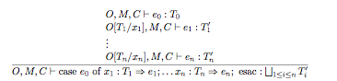

3A. (10 points) Instruction Scheduling
Build a data dependence DAG for the following set of instructions. Also, give the best instruction ordering assuming instructions 1 and 3 take three cycles each and the others take one cycle.
1 | a = b / c
2 | e = c + a
3 | f = a / c
4 | g = f + e
5 | h = b + e

3B. (15 points) Scanning, Parsing, and Symbol Tables
Justify the following TRUE statements with a solid argument. Sometimes an example helps demonstrate your argument better.

1. A lexical analyzer built based on regular expressions will not attempt to detect an improper use of an identifier in an expression.

2. We could implement lexical scanning within a Yacc specification; but no one really implements the scanning process this way.

3. It takes more space to run a program when the language is interpreted rather than compiled.

4. Shift-reduce conflicts are not possible in the LALR(1) parser table constructed for an LR(1) grammar.

5. Symbol table construction typically includes some implementation of a stack of currently active symbol tables.

4A. (15 points) Register Allocation
Consider the following control flow graph. Generate the interference graph for all the variables. What is the smallest k such that the interference graph is k-colorable? Justify your answer.

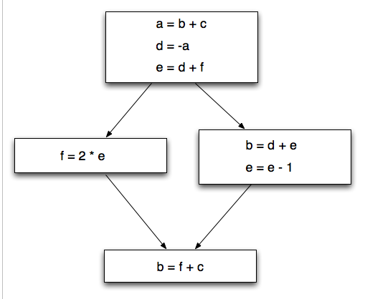

4B. (10 points) Parsing and Grammars
Consider the following grammar:

S -> a b A | a
A -> A c B | B
B -> d | C d C
C -> x | x y

- (6 points) Give three examples to justify why the grammar is NOT LL(1).

- (4 points) Explain what needs to be done to address one of these problems, with a rewriting of the grammar enough to demonstrate you understand the methodology for addressing that problem.

