Adobe Illustrator Lab 1
Illustrator is a vector drawing program. Adobe Photoshop is bitmap-based, which means it is best at dealing with files that contain a grid of dots, and each dot has its own RGB color information. To get a realistic image, we’d need to store a lot of dots. While this is the best way to store and work with images that are photorealistic, it is not the best for images that need to be crisp and sharp when we make the image larger and smaller. For images that do need to be both large and small, (think logos, which show up on business cards, on web pages, and on corporate signs) Illustrator is probably the better choice. Illustrator images are often very crisp and have that graphically-generated appearance (as opposed to the appearance of a photograph or a hand-drawn image). Illustrator uses mathematical equations to draw out the shapes. This makes vector graphics scalable without the loss of resolution.
Advantages of Vector Graphics
- Scalable without resolution loss
- Lines are crisp and sharp at any size
- Images print well at high resolution
- Files are smaller in size
Disadvantages of vector graphics
- Drawings tend to look flat and cartoon-like
- Hard to produce photo realistic drawings
If you have experience with Photoshop, you can bring your Illustrator images into Photoshop and enhance it.

Getting Started in Illustrator

Create New Document
Step 1: File>New Document
Step 2: Type in a name (AIlab1) for the document and then click Advanced (bottom left)
Step 3: Select RGB for Color Mode. Click Ok.

Illustrator Workspace
Below are the workspace and some common terms associated with it. Depending on the version of CS you are using, you may notice to new design for Floating Palette. The rest should look about the same.
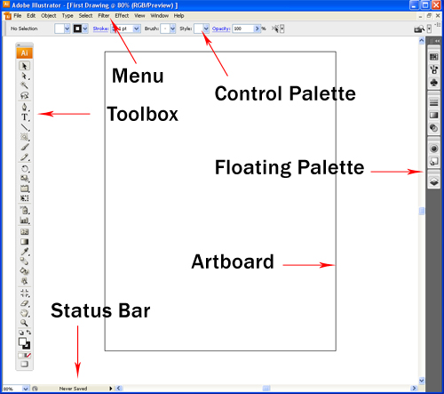

Toolbox
This is the handy toolbox you’ll be using most. By default, it comes in one single column as shown in the screenshot above. To switch it back to the 2 columns toolbox, you can simply click the top left mini arrow to toggle it into 2 columns. Some of the tools like Rectangle have more tools hidden. To expand, just click and hold the icon to reveal all the similar tools under that group. You should recognize a lot of the tools from Photoshop, with a few new ones thrown in.
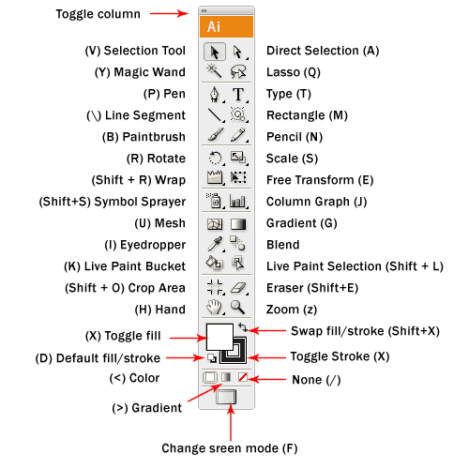

Floating Palette
This is the floating palette which contains properties for shapes. It is commonly used for changing colors and stroke width.
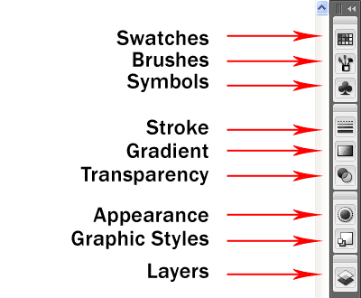

Saving AI Files
Step 1: Select the type tool
Step 2: Click on the artboard (the white space) and type some text.
Step 3: At the top, you should see (among other things) Stroke (which is, in essence, the outline), Character (which, when you click on it, will give you a drop-down menu with options for the character, paragraph (also drop-down menu), Opacity, and Flash Text (with accompanying drop-down menus). Click on the menus and at least look at your options. If you want to try applying any of the options, highlight what you just typed, and select the option. It should be applied immediately.
Step 4: Go to File>Save.
Step 5: Next to “File name:” type, “First Drawing” and next to “Save as type:” select Adobe Illustrator(*.AI) for file type. Click Save.
Step 6: Accept the defaults and click “OK”
You have successfully saved your first file. To make any more changes you can simply open the Adobe Illustrator file.
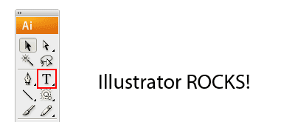

Drawing Basic Shapes

Selection Tools
There are 2 types of selection tools in Illustrator used for selecting objects.
Selection Tool: Used for selecting and moving a shape. It can also be used to resize a shape.
Direct Selection Tool: Selects a single anchor point instead of the whole shape. Used for editing an anchor point of a shape. Click once on a point to select and hold Shift to select multiple anchor points.
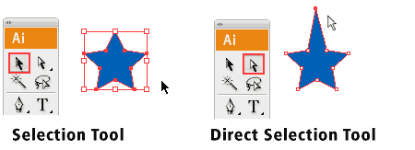
Step 1: go to the rectangle tool in the toolbox (see below) and hold mouse down over it. You should get a pop-up box with a few shaped tools. Select the Star Tool.
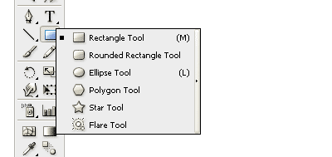
Step 2: Click next to Illustrator Rocks to add a star shape there. Accept the default radius and points, and click OK
Step 3: Select the Selection Tool (above) and click on the star.
Step 4: (A bit tricky) run your mouse near the border of the star’s selection (the red line above, the blue square in illustrator surrounding the star). Your mouse should at some point near the border turn into a curved line with an arrow at both ends. When it does this, you can rotate the star. Click down and drag the star around until one of the points points straight upward (like in the illustration for Selection Tool, above. To snap at 45 degrees increment, hold Shift while turning.

Step 5: Select the Direct Selection Tool (above, right). Now click somewhere outside the star (to deselect the star). Now start skewing your star by clicking carefully on the points and dragging them different directions then on the angles and dragging them as well. Have fun making a weird-looking star.
My Funky Star: 
Step 6: Save the file.
Rectangle Tool:
Step 1: Go to the Tool Palette and hold the Rectangle Tool (as you did above to select the star tool). Choose the Rectangle Tool.
Step 2: Click somewhere on the page below your star. When the Rectangle pop-up box pops up, set the width to 150pt and the height to 75pt. By default, it has a white fill and black stroke. (Stroke is the border of the shape)
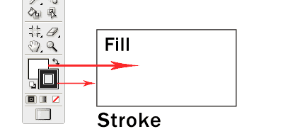

Changing Fill Color
Let’s start changing the fill color for the rectangle.
Step 3: Double click the Fill (above) from the Tool Palette.
The color picker (below) should pop up.
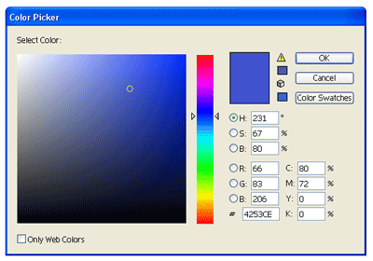
Step 4: Drag the slider to blue and select a deep blue color. Click Ok after that.

Removing Stroke
Step 5: Click the Stroke in the Tool Palette once to swap it above Fill.
Step 6: Click the None icon boxed up in red to set the Stroke to None. The black stroke will disappear.

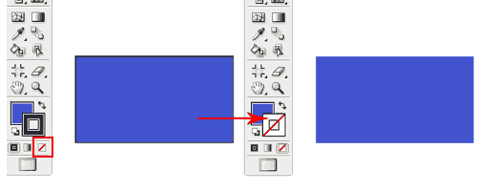
Resizing Shapes
Step 7: As you did for the rectangle and the star, click on the Rectangle Tool and hold it down. Select the polygon tool and add one to the page (use the defaults in the pop-up box).
Step 8: To resize the polygon, select the shape using the Selection Tool. A bounding box will appear.
Step 9: We want to resize the polygon, but with its proportions constrained (so we don’t stretch it out, but resize the entire shape equally. To do this, hold Shift as you drag the corner anchor point to resize it. To constrain to proportion while resizing, resize.
If you want to resize the image in a constrained manner, but having the image’s center staying exactly in the same location (so it’s being resized around the center point, hold shift and simultaneously Alt/Option while dragging a point to resize.
Step 10: Try resizing the polygon around the center by holding the shift and alt/option while dragging a point outward.

More Options for Shape Tools
Step 11: Add another Star. Select the Star Tool. Click once on the artboard and an option will pop up. Enter the same values below and click Ok. It will draw a star burst shape. This method can be used to bring out more options for shape tools.

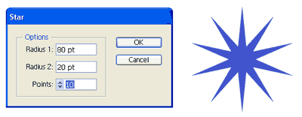
Step 12: Save your file. Yeah, it’s just some funky shapes with a bit of text, but you’re learning illustrator!

Drawing with Pencil Tool

Drawing a Line
Step 1: You should still have the file with the funky shapes on it. Select the pencil tool and click and drag to draw a free hand line drawing.
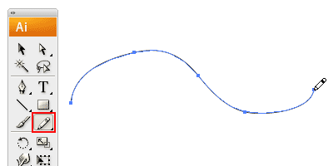

Closing Paths with Pencil Tool
Step 2: Draw another line. This time, as you loop back to the starting point, hold Alt/Option as your Pencil Tool reaches the start point. A circle icon will appear next to the Pencil Tool to indicate path closure.
Aside: If the first line disappears when you draw the second line, make sure the stroke isn’t still off (doesn’t have a red line through it). If it is off, double-click on it (either at the bottom or at the top left) to turn it back on.
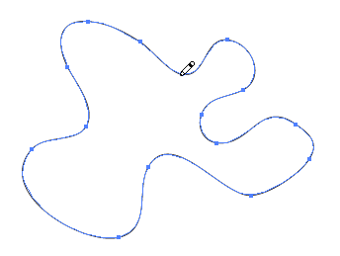

Smoothing Jaggy Lines
Step 3: Normally when you draw with the Pencil Tool, the path looks jaggy. To smooth the parts that are jaggy, simply hold Alt/Option to turn the Pencil Tool to Smooth Tool. Then draw over the area of the lines which you would like to make smooth. If you’re still not satisfied, you can repeat until the line is as smooth as you like.
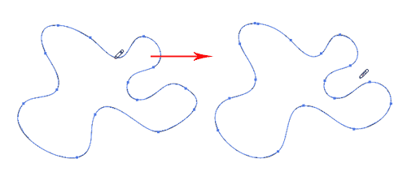

Reshaping Path
Step 4: To reshape the path, make sure the path is selected and use the Pencil Tool to redraw the parts you would like to reshape. Note that the start and end path must be close to the original path for this to work.

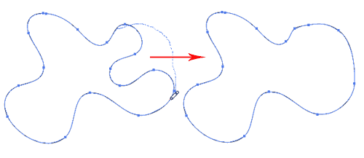

Pencil Tool Options
You can turn on the Pencil Tool Options by double clicking on the Pencil Tool. You can change the fidelity and smoothness to find a combination that works for you.
Fidelity: Determines how close the path is drawn to your mouse movement. Set it at a higher fidelity if you’re not good at drawing with your mouse.
Smoothness: The higher you set for smoothness, the fewer anchor points it produces. Thus, producing a smoother line.
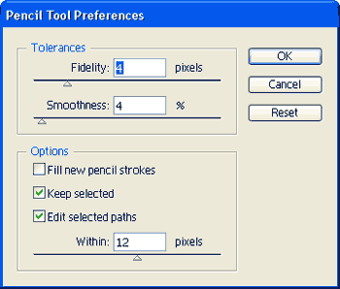
Step 1: Double-click on the pencil tool to bring up the pencil tool options.
Step 2: Set the Tolerance to 1 and the smoothness to 0%
Step 3: Draw a shape on the page with a Fidelity set to .5pixels and a Smoothness set to 0%. Now draw a blob on the page. Notice how many little squares appear on the line you just drew.
Step 4: Double-click on the pencil-tool again to get the pencil tool options.
Step 5: Set the Fidelity to 20 pixels and the Smoothness to 100%.
Step 6. Draw another blob on the page. Notice how many little squares appear on this line. Do you see the difference?
Step 7: We haven’t saved the file in a while, so save it.

Drawing with Pen Tool

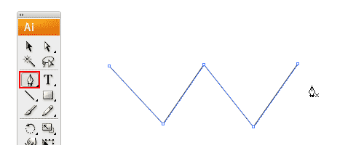

Drawing Straight Lines
Step 1: Select the Pen Tool (above)
Step 2: Click once on the artboard to add the first anchor point. Move your mouse to the next position and click again to create the second point. The two anchor points will be connected together.
Step 3: Continue doing this to create a W shape as shown above.
If you want to draw a new line, click the Selection Tool (The Black Arrow Icon at the top) and click back on the Pen Tool again.

Closing a Path
To close a path, click back the starting point to close the shape.
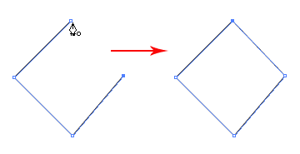
Step 4: On your crazy, wacky artboard, create a closed path, like the cube above.
Step 5: Save the file

Drawing a Curved Line
Step 6: Click on and hold down on the pen tool in the sidebar.
Step 7: Select the Convert Anchor Point Tool (at the bottom)
Step 8: Click and drag to put out the handles to create a smooth anchor point.
Step 9: Run your pointer over an anchor point on the w-shape you created on. You should see a small green word “anchor” when you’re over the anchor point.
Step 10: Click and drag your mouse away from the anchor point. You should see one of the lines of the w start to curve.
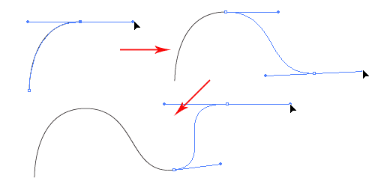

Drawing a Circular Path
For this, you’ll use the pen tool again.
Step 11: Reselect the pen tool.
Step 12: In the Artboard, click and (without releasing) immediately drag out a bit. Now click a bit away from the first click and (without releasing) immediately drag out. Keep clicking and dragging in a circular path. All your lines should be slightly curved. When you are done yoru circle, click back the starting point to close the path. Yeah, it will be a funky circle, but you should have created a circular object.
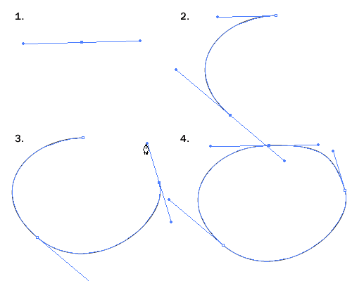

Adding Anchor Points
Step 13: With the Pen Tool selected, go near the path where you want to add a new anchor point. A plus sign will appear next to the pen, click on the path to create a new anchor point.
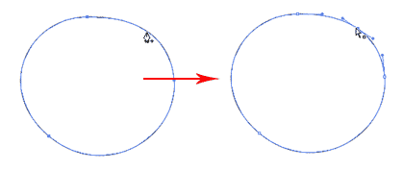

Removing Anchor Points
Step 14: Move your Pen Tool close to an anchor. A minus sign will appear next to the pen. Click on the anchor point to delete it.
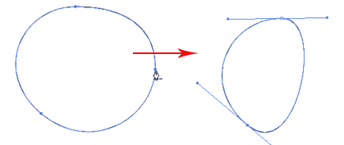

Converting Anchor Points
Step 15: To convert a smooth anchor point to a sharp anchor point, move your Pen Tool near the anchor and hold Alt/Option and your Pen Tool will change to an arrow shape.
Step 16:Click on the smooth anchor (I’d choose one without too many other anchor points nearby) to convert it to an anchor point.
Your circular blob should now have a point. If you wanted to convert it back, you’d click and drag on the anchor point again to change it back to a smooth anchor point.
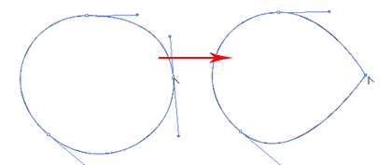

Moving Anchor Points
Step 16: Select the Direct Selection Tool (second down from the very top of the toolbar) and click and on anchor you want to move (make sure you’re over the anchor point itself, and not the handles belonging to the anchor).
Step 17: Click and drag the anchor somewhere new to change its position.
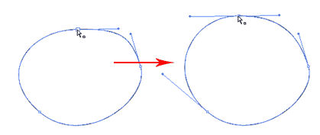
Step 18: Save your file and close it.

Practice: Drawing a Key Shape
Tips for Using Pen Tool
- Use as few anchor points as you can to create your shape
- Add anchor points where there is a change in direction of the line/curve
- Hold shift to lock your path while adding new anchor point for 45-degree increments.
- For the right angles, hold Shift before adding anchor point to constrain it to 90-degree.
Step1: Open a new file. Give it the name PenPractice. Click advanced->RGB.
Step 2: Create the following (left, then add to left to make right)
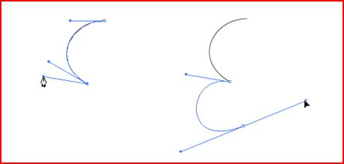
Step 3: Add the following to what you’ve already created:
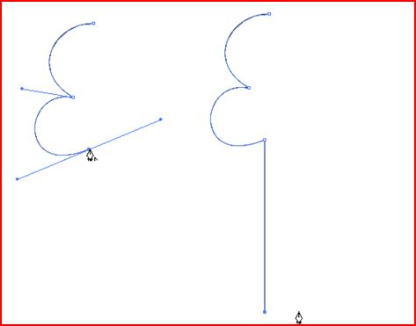
Step 3: Add the following:
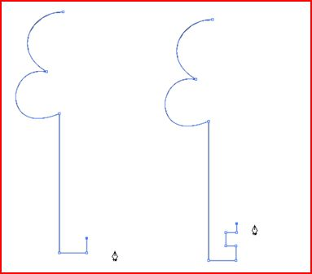
Step 5: Add the following:
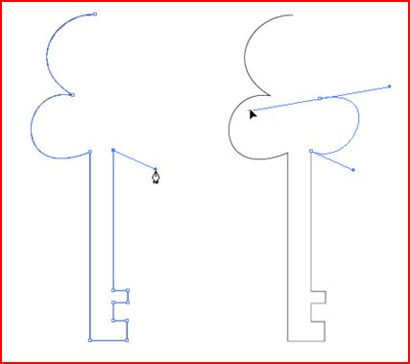

Step 6: Add the following:
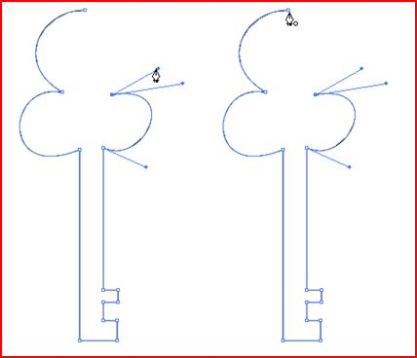
Step 7: Add the following:
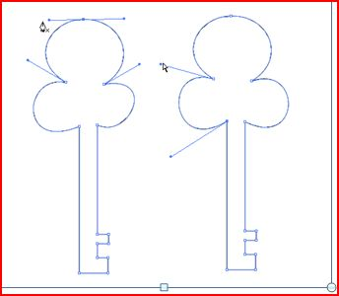

Step 8: Save your file. This is what your final drawing should look like:
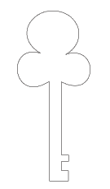

More Practice

Step 9: Create 2 of the following shapes.
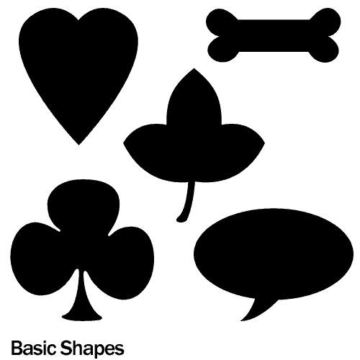
Step 10: Create 1 of the following shapes:
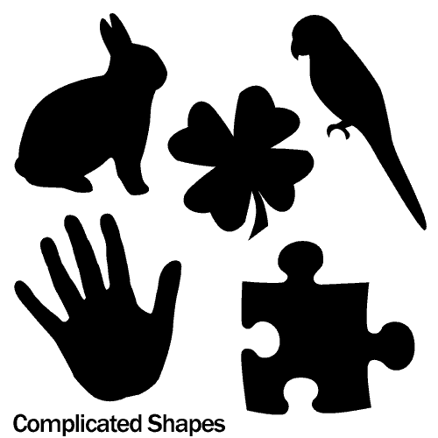

Step 11: Save your file

To Turn In:
- AIlab1
- PenPractice

