CISC103 Homework 2:
  - Due Sunday at Midnight
Create a folder called HWK2. Go into that folder and do all of the following :
HTML Web Page:
- From the template you created last week, create a second web page. Save it with a name other than template.html (hwk2.html works).
- Include a title, at least 2 different headers, and a paragraph.
- Below that, include an unordered list
- Include an ordered list as one of the list items in an ordered list.
Note: the default for tables is to have no border. But if we want to see the edges of the cells in a table, the best way to do it is to use CSS to specify that we want a border. Of course, we haven’t learned CSS yet. So for now, at the top of your web page (right below the title but above the </head> tag) paste the following css:
<style>
table { border-width: 1px;
border-style: solid;
}
td { border-width: 1px;
border-style: solid;
}
</style>

- Include a table with headers at the top of each column
- Create a table that holds the following questions in the left column, and answers those questions in the right column:
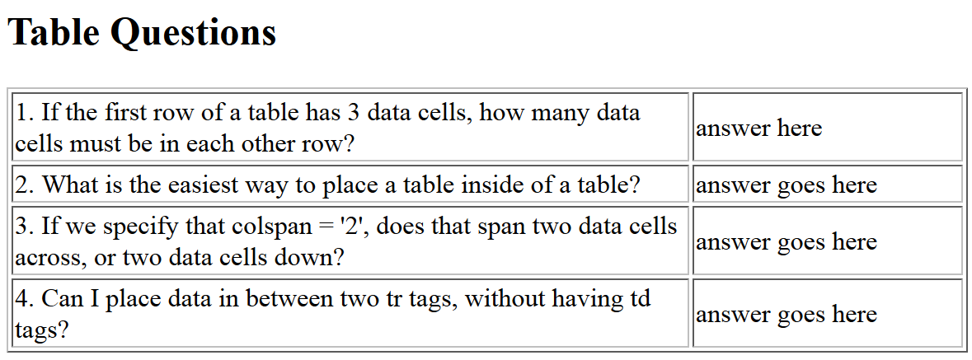
- Include a table that looks like the table below (using tables within tables: in the bottom row each data cell holds a tables)
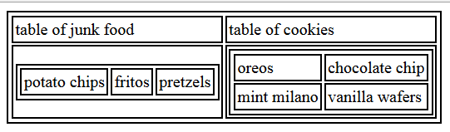
- Create a table that looks like this (using colspan and rowspan) – this is one table only:
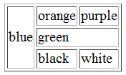
- Make sure the second html page validates!!! Use validator.w3c.org to upload the hwk2.html page, and make sure you get the green Congratulations bar.
Upload the entire HWK2 folder to the University’s web server. Make sure the permission for both the HWK2 folder and the hwk2.html file have been set appropriately and turn in the URL via Sakai.

