CISC103 Homework 1:
  - Due Sunday (Sept 7) at Midnight
You will be turning in 3 separate files: one text file with the answers to questions 1-5, and one html template (with the very basic html tags) and a second html file made from the template in which you implement 7-13. All 3 pages should be uploaded to the server (as per lab on Friday), and the urls of each submitted on Sakai.
Alternative: You can include the answers to questions 1-5 as either paragraphs or an ordered list in your HTML Web page you’re creating. Kill two birds with one stone.
Internet Questions:

What is your TA’s name and email address?

Briefly (in two sentences or less) what is the difference between TCP/IP and HTTP?

Define the term: URL

Briefly describe the client-server model.

What two things does the browser do?

HTML Template:
- Create an html template. Make sure it validates using the w3c validator.
HTML Web Page:
- From the template, create a second web page, in which you include a title, at least 2 different headers, and a paragraph.
- In that second web page, include an unordered list
- Include an ordered list as one of the list items in an ordered list.
- Include a table with headers at the top of each column.
- Include a table that looks like the table below (using tables within tables: the bottom row consists of two tables)
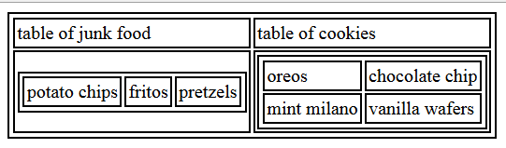
- Create a table that looks like this (using colspan and rowspan) – this is one table only:
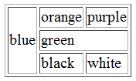
- Make sure the second html page validates!!!
Turn in the template html page and the second html page as well via sakai

