CISC103 Homework 2
Due Sunday at midnight
- Create an html template. Make sure it validates.
- From the template, create a second web page, in which you include a title, at least 3 different headers, and 2 paragraphs.
- In that second web page, include an unordered list
- Include an ordered list.
- Include an unordered list in which at least one list item includes 2 paragraphs.
- Include an ordered list as one of the list items in an ordered list.
- Include a table.
- Include a table with headers at the top of each column.
- Include a table that looks like the table below (using tables within tables
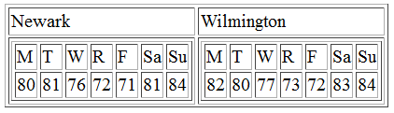
- Create a table that looks like this (using colspan and rowspan):
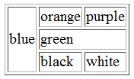

Make sure the second html page validates!!!
Turn in the template html page and the second html page as well via sakai

