Performance Analysis of Cost Optimization Algorithms
In Multimedia Gateway Call Routing

Qiwei Huang
UTStarcom Inc.
33 Wood Ave. South, Iselin, NJ 08830,U.S.A.
qhuang@utstar.com
Errol Lloyd
Dept. of Computer and Information Sciences
University of Delaware, Newark, DE 19716,U.S.A.
elloyd@cis.udel.edu

Abstract: Multimedia gateways are a recently emerged next generation telecommunication product that provides real-time, multi-way communications among different media networks, such as Public Switched Telephone Networks (PSTN), IP networks and wireless networks. When a call arrives at a multimedia gateway from a local media network, that gateway must route the call to one of the non-local media networks to reach the destination. In addition to call delay, which is measured by delay cost, calls routed to different media incur varying media costs. This paper investigates algorithms on multimedia gateways in regard to call routing aimed at minimizing the expected routing cost, which is the media cost plus the delay cost. We assume that calls have a Poisson arrival rate and exponentially distributed length. Both centralized and distributed queuing models are considered, and performance measures are derived.
Keywords: Multimedia gateway, Call routing, Cost optimization.

1. INTRODUCTION
Multimedia gateways interconnect different media networks (e.g. IP, PSTN, wireless, etc) and provide real-time, multi-way communications among them. The functionalities of multimedia gateways include call routing, call signaling conversions and media conversions. In regard to call routing, this paper studies algorithms to minimize the expected routing cost, which is the media cost plus the delay cost. In the remainder of this section, we briefly review multimedia gateway architectures and functionalities. In section 2, we describe the problem in detail. In section 3, we present our algorithms and analysis. Finally in section 4, we give our conclusions.

1.1 General Background Review
A typical multimedia gateway interconnection [1] is shown in Figure 1-1. There, two multimedia gateways, NYC and LA, are interconnected by three media networks: IP, PSTN and wireless. Each user is connected to a single local network. Each local network is connected to a single gateway. Figure 1-2 illustrates the internal architecture of a multimedia gateway [1]. A central controller is connected to each media controller through a control bus. Each media controller has its physical media interface connected to the media network, and it is responsible for the media access control.
Multimedia gateways perform three high-level functionalities [1]: call signaling conversions, media conversions and call routing. Since call signaling conversions and media conversions are not relevant to this paper, interested readers can refer to [1,2] for additional details.

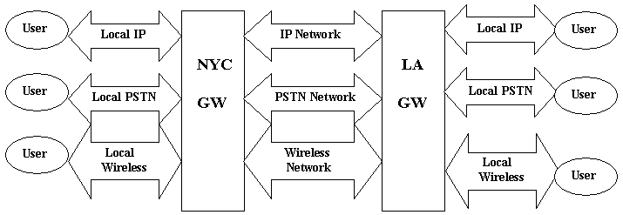
Figure 1 Multimedia Gateway Interconnection.

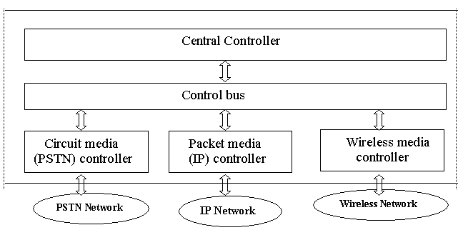
Figure 2 Multimedia Gateway Internal Architecture.

1.2 Call Routing Review
When a call arrives at a multimedia gateway from a local media network, that gateway must allocate that call to one of the non-local media networks associated with the gateway. This is the functionality of call routing [1]. A channel is a physical resource that transmits and receives voice/data information. Each call is processed by one and only one channel, and cannot be pre-empted. Each media’s bandwidth is the number of channels available on that media. We assume that the bandwidth for routing calls to the non-local media networks is fixed. In centralized queuing, the queuing of the calls is completely handled at the central controller. The central controller decides when to route the calls depending on real time information about channel utilization as provided by each media controller. In distributed queuing, the queuing of the calls is distributed into each media controller. Each media controller decides when to process the calls routed by the central controller based on its channel utilization. Relevant to call routing, there are three costs. Media cost: Calls routed to different non-local media networks incur different media costs. Delay cost: When a call can’t be routed to a non-local media network upon its arrival due to the bandwidth limitation, a delay cost is incurred. Routing Cost: The routing cost is the media cost plus the delay cost. Note that the expected routing cost of a multimedia gateway is independent of the expected routing cost of the other gateways. Thus, throughout this paper, our focus is on a single multimedia gateway’s call routing in its non-local media networks.
Note that we can reasonably assume that the number of calls arrived/completed in one time interval is independent of the number of calls arrived/completed in another time interval. We can further assume that the call arrival and departure rates are constant over a period of time. Thus we use a Poisson process to model call arrival and departure.

2. PROBLEM DESCRIPTIONS
Considering a single multimedia gateway, the call arrival rate is a Poisson process with parameter and each call has an exponential call length with parameter . The unit time delay cost is for each call. We assume that the size of the queue (for calls that cannot be processed immediately) is infinite. There are K non-local media networks connected to the multimedia gateway. Each media, denoted by , has unit time media cost for each call processed on this media. Without loss of generality, we assume that . The bandwidth of is , which is the maximum number of calls that can be processed simultaneously. Let be the total bandwidth of all media. The goal of routing is to minimize the expected routing cost of calls.
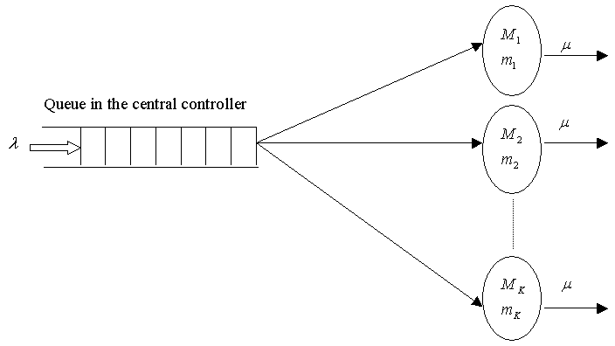
Figure 3 Centralized Queuing Model

A centralized queuing gateway has one central queue in the central controller (Figure 3) [1]. The central controller routes a call immediately if there is an idle channel on any of its media. Otherwise, it places the call into the central queue and routes it later on a first come first served basis as soon as a channel becomes available on any of its media.
A distributed queuing gateway has one queue in each of its media controllers (Figure 4) [1]. After the central controller routes a call to one of the media controllers, the media controller processes the call immediately if there is an idle channel on that media; otherwise it places the call into its queue and processes it later on a first come first served basis as soon as a channel on that media becomes available.

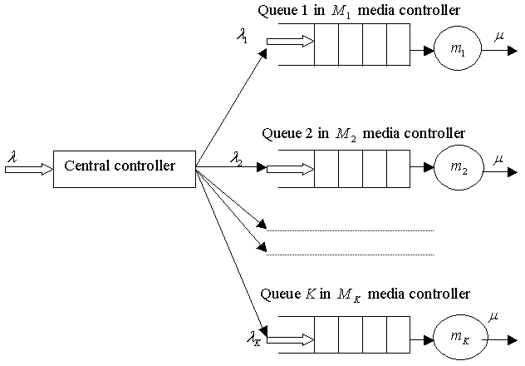
Figure 4 Distributed Queuing Model

3. ROUTING PERFORMANCE ANALYSIS
In this section, we present our main results. In sections 3.1 and 3.2, we describe two routing algorithms: a greedy algorithm and a traffic splitting algorithm. These two algorithms are designed respectively for the centralized queuing model and the distributed queuing model. Sections 3.1 and 3.2 also contain the analysis of the algorithm performance, and for traffic splitting, a determination of optimal parameters for use in that algorithm. In section 3.3, we compare the performance of the two algorithms.

3.1 The Greedy Algorithm
A natural approach with centralized queuing is to utilize a traditional greedy algorithm: Upon the arrival of a call, if there is an idle channel on some media, the algorithm routes the call to the cheapest media where the call can be processed immediately; otherwise, the call is placed into the central queue and is routed later on a first come first served basis when a channel on any media becomes idle.
The performance of the greedy algorithm in terms of the expected routing cost consists of the expected delay cost and the expected media cost. Recall that is the total bandwidth of all media. If we let be the expected queuing time of a call, then from [1] and [4], is the expected queuing time of an M/M/m queue [3]:
(3.1)
The expected delay cost (3.2)
To derive the expected media cost, let be the state where there are calls being processed by media and q calls are in the queue. Let be the probability that the system is in state . Let be the probability that there are i calls being processed by and the total number of calls in the system is no more than m. Let be the expected number of calls being processed by media and let N be the total expected number of calls being processed by all media at an arbitrary time instant in the steady state. Then, from [3], we have:
(3.3)
The expected media cost of a call is:
(3.4)
where (3.5)
Letting be the probability that there are totally i calls in the system, we have: (3.6)
From [3], (3.7)
Thus can be determined by (3.6) and (3.7). To solve in (3.5), we need to solve . Let be the state that there are calls being processed by the first i media, there are calls being processed by the rest of the media and there are q calls in the queue. Let be the probability that the system is in state . Thus, from the greedy algorithm, when , q is always 0. Let
(3.8)
The state transitions are as follows:
1. When a call arrives with rate , the state will change to if .
2. When a call arrives with rate , the state will change to if .
3. When a call arrives with rate, the state will change to if .
4. When a call in first i media finishes with rate , the state will change to if .
5. When a call in non first i media finishes with rate , the state will change to if .
6. When a call finishes with rate , the state will change to if .

The state transition diagram is shown in figure 5. Note that we simplify all of the states in the dotted line from to since q is always 0. Let be the probability that there are j calls being processed by the first i media and the total number of calls being processed is no more than m, thus:
(3.9)
From (3.9) and the greedy algorithm, we have:
(3.10)
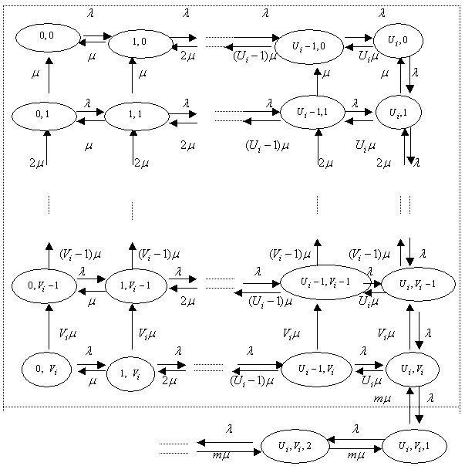
Figure 5 The State transition diagram
From (3.10), we have:
(3.11)
Note that
(3.12)
When the total number of calls being processed is no more than m, the expected number of calls being processed by is equal to the expected number of calls being processed by the first i media minus the expected number of calls being processed by the first i-1 media. Thus,
(3.13)
From (3.6) to (3.12),
(3.14)
Thus can be calculated. From (3.5), can be calculated. From (3.4), can be calculated. It can be verified that (3.5) satisfies (3.3). The expected routing cost is: (3.15)
Although the greedy algorithm seems apparent, it is in fact optimal as the next result shows:
Theorem (3.16) Among all algorithms for the centralized queuing model, the greedy algorithm minimizes the expected routing cost.
Proof: Recall that for the centralized queuing model, the gateway routes and processes a call immediately if there is an idle channel on any of its media. Suppose there exists an algorithm A that minimizes the expected media cost in the centralized queuing model. Without loss of generality, suppose there are two media and , and each media has one channel. Further suppose that the algorithm A consecutively routes and processes any two calls at the time and (), and two channels on the two media are idle at the time . It is trivial that when , two calls are routed to the two media for processing. Note that it is “greedy” routing. When , if the algorithm A routes call , it is “greedy” routing; if the algorithm A routes call , let be the time that both two channels on the two media become idle again (i.e. during the time , at least one channel is busy). Obviously, ; otherwise, call could be routed to without affecting other calls’ routing to yield less expected media cost, and it contradicts the assumption that the algorithm A minimizes the expected media cost. Since each call length is exponentially distributed with the same parameter , it can be easily seen that during the time , the expected number of calls processed on media is not less than the expected number of calls processed on media . Thus during the time , if all the calls routed to (including call ) are routed to , and all the calls routed to (including call ) are routed to , the expected media cost will not increase. This shows that in terms of routing calls , it is a “greedy” routing. Since calls are any two calls, we conclude that the greedy algorithm minimizes the expected media cost. From [1], we know that the greedy algorithm minimizes the expected queuing delay, thus it also minimizes the expected delay cost. We finally conclude that the greedy minimizes the expected routing cost.
Ex. (3.17)
By (3.1), ,. By (3.14), . By (3.13) and (3.5), . From (3.3), . From (3.4), (3.15), .
Ex. (3.18)
Similarly, ,
,,, , .
These two examples have the same system parameters except , thus they have the same , and , since the expected queuing delay and expected number of calls processed by each media is decided only by each media’s bandwidth as well as and , not media cost. in example (3.18) is larger than in example (3.17) because example (3.18) has a larger . In both examples, some calls will necessarily be routed to media 2.

3.2 The Traffic Splitting Algorithm
In this section, we introduce a traffic splitting algorithm to route the calls (split the traffic) to each media controller with predetermined probability to achieve the minimum expected routing cost. We analyze the performance of the algorithm by showing how to derive such a predetermined probability and we prove its correctness. Then we present some examples.
We know that the call arrival rate at a multimedia gateway is a Poisson process with rate . We split the traffic according to probabilities to the media where . According to [3], the call arrival rate at media is also a Poisson process with rate . Let be the expected waiting time for a call routed to the media , and let be the expected waiting time of a call. Then utilizing the determination of queuing delay from [1], is given by:
(3.19)
can be determined using (3.1) with m replaced by , replaced by and replaced by :
(3.20)
where (3.21)
Then, the expected media cost of a call:
(3.22)
Finally, the expected routing cost of a call:
(3.23)
If K=1, then , and are fixed. Thus we assume K>1. Let (3.24)
From (3.21), we treat as independent variables, and depends on . Thus,
(3.25)
(3.26)
Note that (3.26) is the first partial derivative of the expected routing cost with respect to , and it is used by the Traffic_Splitting algorithm described below (recall that we assume ).
-----------------------------------------------------------------------------
Algorithm (3.27) Traffic_Splitting()
{
1. For j←1 to K do if , goto step 2;
2. While j<=K
a. if j=1,
b. else
calculate that satisfies and by using Newtons’ method for the non-linear equations described in [4];
if j=K goto step 3;
c. (note that ).
- if , then
for i←j to K do ; goto step 3;
e. else j←j+1;
3. Route calls to with probability ;
}
Figure 6 The Traffic Splitting Algorithm

The algorithm works as follows: step 1 finds the first j media that satisfy . Step 2.a and step 2.b find the unique that minimizes for the first j media. Then we have (we prove it later). If j=K, then has been found. Otherwise if , step 2.d set and has been found. If, step 2.e increases j and continues with step 2. Note that for a given set of system parameters, steps 1 and 2 can be performed off-line. The complexity of the algorithm is determined by the complexity of Newton’s method [4]. Interested readers can refer to [4] for more detail. The following theorem shows the correctness of the Traffic_Splitting algorithm (the proof is in the appendix):
Theorem (3.28): The Traffic_Splitting algorithm correctly finds the unique that minimizes .
Ex. (3.29)
Step 1: finds j=1, since .
Step 2.a: sets .
Step 2.c: from (3.20), , from (3.24), Step 2.d: sets , increases j to 2. Since j=K, the algorithm terminates with .
This example shows that when one media has a relatively large unit time media cost ( in this case), the traffic allocated to this media can be zero ( in this case) in order to minimize the expected routing cost. Suppose in this example, we add more media with (), then after step 2.d, step 3 will set , ending up with the same .
Ex. (3.30)
Steps 1-2.a: finds j=1 (), sets .
Step 2.c: from (3.20), , from (3.24), Step 2.e: increase j to 2 and go back to step 2.b.
Step 2.b: from (3.20), , . From (3.19), (3.22) and (3.23), we have and . Let , using Newton’s method, . Since j=K, the algorithm terminates with .
Note that the system parameters in this example are the same as in example (3.29) except for a smaller . It shows that when each media has similar unit time media cost, in order to minimize , the traffic allocated to media should be greater than zero.

3.3 Performance Comparison
Generally speaking, for the same set of system parameters, if unit time delay cost takes dominance over each media’s unit time media cost , is usually less than . The reason is that the expected delay for the centralized queuing model is less than the expected delay for the distributed queuing model [1]. On the other hand, if some media has an unusually large unit time media cost, then may be larger than , since the traffic splitting algorithm takes each media’s unit time media cost into consideration when it “splits” traffic: if some media has a fairly large unit time media cost, the traffic splitting algorithm may not allocate any traffic on that expensive media. But the greedy algorithm still has to route calls to the expensive media if only that expensive media has idle channels. Example (3.29) has the same set of system parameters as in example (3.18). We can see that in example (3.18) is larger than in example (3.29). Example (3.30) has the same set of system parameters as in example (3.17). We can see that in example (3.17) is less than in example (3.30).
Thus, given the same set of system parameters, in order to obtain a better minimal expected routing cost, the choice of either the greedy algorithm for the centralized queuing model or the traffic splitting algorithm for the distributed queuing model depends on each specific system parameter. However, the greedy algorithm minimizes the expected routing cost among all algorithms for centralized queuing model, and the traffic splitting algorithm minimizes the expected routing cost among all algorithms for distributed queuing model.

4. CONCLUSIONS
In this paper, we reviewed the multimedia gateway architecture and functionalities as introduced in [1]. We presented two algorithms to minimize the expected routing cost for the centralized queuing model and the distributed queuing model respectively. We analyzed and compared the performance of the two algorithms, and we proved the correctness of the two algorithms.

References
[1] Qiwei Huang & Errol Lloyd, Analysis of Queuing Delay in Multimedia Gateway Call Routing, p193-198, Proceedings of the International Conference on Internet Computing (IC2002).
[2] ITU-T H.323 Packet-Based Multimedia Communications Systems. Series H: A.M.S, 11/2000.
[3] ITU-T H.225.0 Call Signaling Protocols and Media Stream Packetization for Packet-based Multimedia Communication Systems. Series H: A.M.S., 11/2000.
[4] R. Nelson, Probability, Stochastic Procedures, and Queuing Theory. Springer-Verlag, 2000.
[5] L. V.Fausett, Applied Numerical Analysis Using MetLab. Prentice Hall, 1999.

Appendix
Proof of theorem (3.28): Recall again that we assume . Let be the call distribution vector that minimizes . If in the first j media (j<K) , which implies , then there is at least one media in the first j media that satisfies . From (3.20), , thus . But from the assumption (3.21), it is always possible to find a call distribution vector , such that , i.e. , thus , thus . This contradicts the fact that minimizes . Thus step 1 of the algorithm is correct.
Let be the expected routing cost of the first i media (). Suppose in the first j media (), and, which implies . It is trivial that when j=1, minimizes . When j>1, we first prove that exists. From (3.26),
(3.31)
From [1] and (3.24), (3.32)
From (3.25), (3.33)
From (3.31), (3.32) and (3.33), we take second derivative of in term of :
(3.34)
Thus (3.31) is a monotonous increasing function in term of . When . Since , thus
. When , . Since , we can always let , then . We conclude that exists.
We then prove that the fist execution of step 2.b in the algorithm correctly finds a unique that minimizes . We let and define the following matrix:
Let . From advanced calculus, minimizes if and only if for each i=1,…,j-1. Let , from (3.32) (3.35)
From (3.33) and (3.25),
(3.36)
From derivative property, . From (3.35) and (3.36), it is easy to verify that . Now suppose , we prove that .
= …
Obviously, if j=K, minimizes . The uniqueness of can be easily proved by using induction on j and the property (3.32). Thus we have proved that the fist execution of step 2.b in the algorithm correctly finds a unique that minimizes .
Recall that j represents the first j media that satisfy and . Since exists, from (3.31), . Thus .
We can prove similarly that if , then: exists; there is a unique decided by and such that minimizes ;; . Obviously, if j+1=K, () minimizes . Thus we have proved that the second execution of step 2.b in the algorithm correctly finds a unique () that minimizes . We can prove similarly that during each loop of step 2, step 2.b in the algorithm is correct.
From the above conclusions, we now suppose in the first media, we have found a unique that minimizes , , . If , we first prove that there is a unique a unique that minimizes . Let the optimal value of be and the optimal value of be . If we change to , then let be the expected routing cost of the first media, let be its optimal value. From the assumptions above, we have , and . Note that it can be verified that satisfies , thus minimizes . Then and . It can be easily shown that also minimizes , and such is unique. It can be further shown easily (we omitted the proof here) that minimizes , i.e. , and such is unique. Thus the step 2.d in the algorithm is correct, and the theorem is established.

